**Step #1: sudo apt-get update**

ubuntu@ip-10-0-0-32:~$ **sudo apt-get update**

Hit:1 http://us-west-2.ec2.archive.ubuntu.com/ubuntu bionic InRelease

Hit:2 http://us-west-2.ec2.archive.ubuntu.com/ubuntu bionic-updates InRelease

Hit:3 http://us-west-2.ec2.archive.ubuntu.com/ubuntu bionic-backports InRelease

Hit:4 http://security.ubuntu.com/ubuntu bionic-security InRelease

Hit:5 https://packages.cloud.google.com/apt kubernetes-xenial InRelease

Reading package lists... Done

ubuntu@ip-10-0-0-32:~$ sudo apt install -y default-jdk

Reading package lists... Done

Building dependency tree

Reading state information... Done

The following additional packages will be installed:

at-spi2-core ca-certificates-java default-jdk-headless default-jre default-jre-headless fontconfig-config fonts-dejavu-core fonts-dejavu-extra java-common libasound2

libasound2-data libatk-bridge2.0-0 libatk-wrapper-java libatk-wrapper-java-jni libatk1.0-0 libatk1.0-data libatspi2.0-0 libavahi-client3 libavahi-common-data

libavahi-common3 libcups2 libdrm-amdgpu1 libdrm-common libdrm-intel1 libdrm-nouveau2 libdrm-radeon1 libdrm2 libfontconfig1 libfontenc1 libgif7 libgl1 libgl1-mesa-dri

libglapi-mesa libglvnd0 libglx-mesa0 libglx0 libice-dev libice6 libjpeg-turbo8 libjpeg8 liblcms2-2 libllvm9 libnspr4 libnss3 libpciaccess0 libpcsclite1

libpthread-stubs0-dev libsensors4 libsm-dev libsm6 libx11-dev libx11-doc libx11-xcb1 libxau-dev libxaw7 libxcb-dri2-0 libxcb-dri3-0 libxcb-glx0 libxcb-present0

libxcb-shape0 libxcb-sync1 libxcb1-dev libxcomposite1 libxdamage1 libxdmcp-dev libxfixes3 libxft2 libxi6 libxinerama1 libxmu6 libxpm4 libxrandr2 libxrender1

libxshmfence1 libxt-dev libxt6 libxtst6 libxv1 libxxf86dga1 libxxf86vm1 openjdk-11-jdk openjdk-11-jdk-headless openjdk-11-jre openjdk-11-jre-headless x11-common

x11-utils x11proto-core-dev x11proto-dev xorg-sgml-doctools xtrans-dev

Suggested packages:

libasound2-plugins alsa-utils cups-common libice-doc liblcms2-utils pcscd lm-sensors libsm-doc libxcb-doc libxt-doc openjdk-11-demo openjdk-11-source visualvm

libnss-mdns fonts-ipafont-gothic fonts-ipafont-mincho fonts-wqy-microhei | fonts-wqy-zenhei fonts-indic mesa-utils

The following NEW packages will be installed:

at-spi2-core ca-certificates-java default-jdk default-jdk-headless default-jre default-jre-headless fontconfig-config fonts-dejavu-core fonts-dejavu-extra java-common

libasound2 libasound2-data libatk-bridge2.0-0 libatk-wrapper-java libatk-wrapper-java-jni libatk1.0-0 libatk1.0-data libatspi2.0-0 libavahi-client3 libavahi-common-data

libavahi-common3 libcups2 libdrm-amdgpu1 libdrm-intel1 libdrm-nouveau2 libdrm-radeon1 libfontconfig1 libfontenc1 libgif7 libgl1 libgl1-mesa-dri libglapi-mesa libglvnd0

libglx-mesa0 libglx0 libice-dev libice6 libjpeg-turbo8 libjpeg8 liblcms2-2 libllvm9 libnspr4 libnss3 libpciaccess0 libpcsclite1 libpthread-stubs0-dev libsensors4

libsm-dev libsm6 libx11-dev libx11-doc libx11-xcb1 libxau-dev libxaw7 libxcb-dri2-0 libxcb-dri3-0 libxcb-glx0 libxcb-present0 libxcb-shape0 libxcb-sync1 libxcb1-dev

libxcomposite1 libxdamage1 libxdmcp-dev libxfixes3 libxft2 libxi6 libxinerama1 libxmu6 libxpm4 libxrandr2 libxrender1 libxshmfence1 libxt-dev libxt6 libxtst6 libxv1

libxxf86dga1 libxxf86vm1 openjdk-11-jdk openjdk-11-jdk-headless openjdk-11-jre openjdk-11-jre-headless x11-common x11-utils x11proto-core-dev x11proto-dev

xorg-sgml-doctools xtrans-dev

The following packages will be upgraded:

libdrm-common libdrm2

2 upgraded, 89 newly installed, 0 to remove and 72 not upgraded.

Need to get 267 MB of archives.

After this operation, 728 MB of additional disk space will be used.

Get:1 http://us-west-2.ec2.archive.ubuntu.com/ubuntu bionic-updates/main amd64 libjpeg-turbo8 amd64 1.5.2-0ubuntu5.18.04.4 [110 kB]

Get:2 http://us-west-2.ec2.archive.ubuntu.com/ubuntu bionic-updates/main amd64 x11-common all 1:7.7+19ubuntu7.1 [22.5 kB]

Get:3 http://us-west-2.ec2.archive.ubuntu.com/ubuntu bionic/main amd64 libice6 amd64 2:1.0.9-2 [40.2 kB]

Get:4 http://us-west-2.ec2.archive.ubuntu.com/ubuntu bionic/main amd64 libsm6 amd64 2:1.2.2-1 [15.8 kB]

Get:5 http://us-west-2.ec2.archive.ubuntu.com/ubuntu bionic/main amd64 fonts-dejavu-core all 2.37-1 [1041 kB]

Get:6 http://us-west-2.ec2.archive.ubuntu.com/ubuntu bionic/main amd64 fontconfig-config all 2.12.6-0ubuntu2 [55.8 kB]

Get:7 http://us-west-2.ec2.archive.ubuntu.com/ubuntu bionic/main amd64 libfontconfig1 amd64 2.12.6-0ubuntu2 [137 kB]

Get:8 http://us-west-2.ec2.archive.ubuntu.com/ubuntu bionic/main amd64 libxrender1 amd64 1:0.9.10-1 [18.7 kB]

Get:9 http://us-west-2.ec2.archive.ubuntu.com/ubuntu bionic/main amd64 libxft2 amd64 2.3.2-1 [36.1 kB]

Get:10 http://us-west-2.ec2.archive.ubuntu.com/ubuntu bionic/main amd64 libxinerama1 amd64 2:1.1.3-1 [7908 B]

Get:11 http://us-west-2.ec2.archive.ubuntu.com/ubuntu bionic/main amd64 libxxf86dga1 amd64 2:1.1.4-1 [13.7 kB]

Get:12 http://us-west-2.ec2.archive.ubuntu.com/ubuntu bionic/main amd64 libxxf86vm1 amd64 1:1.1.4-1 [10.6 kB]

Get:13 http://us-west-2.ec2.archive.ubuntu.com/ubuntu bionic-updates/main amd64 libdrm-common all 2.4.101-2~18.04.1 [5560 B]

Get:14 http://us-west-2.ec2.archive.ubuntu.com/ubuntu bionic-updates/main amd64 libdrm2 amd64 2.4.101-2~18.04.1 [32.3 kB]

Get:15 http://us-west-2.ec2.archive.ubuntu.com/ubuntu bionic/main amd64 libatspi2.0-0 amd64 2.28.0-1 [59.6 kB]

Get:16 http://us-west-2.ec2.archive.ubuntu.com/ubuntu bionic/main amd64 libxtst6 amd64 2:1.2.3-1 [12.8 kB]

Get:17 http://us-west-2.ec2.archive.ubuntu.com/ubuntu bionic/main amd64 at-spi2-core amd64 2.28.0-1 [47.9 kB]

Get:18 http://us-west-2.ec2.archive.ubuntu.com/ubuntu bionic-updates/main amd64 java-common all 0.68ubuntu1~18.04.1 [14.5 kB]

Get:19 http://us-west-2.ec2.archive.ubuntu.com/ubuntu bionic-updates/main amd64 libavahi-common-data amd64 0.7-3.1ubuntu1.2 [22.1 kB]

Get:20 http://us-west-2.ec2.archive.ubuntu.com/ubuntu bionic-updates/main amd64 libavahi-common3 amd64 0.7-3.1ubuntu1.2 [21.6 kB]

Get:21 http://us-west-2.ec2.archive.ubuntu.com/ubuntu bionic-updates/main amd64 libavahi-client3 amd64 0.7-3.1ubuntu1.2 [25.2 kB]

Get:22 http://us-west-2.ec2.archive.ubuntu.com/ubuntu bionic-updates/main amd64 libcups2 amd64 2.2.7-1ubuntu2.8 [211 kB]

Get:23 http://us-west-2.ec2.archive.ubuntu.com/ubuntu bionic-updates/main amd64 liblcms2-2 amd64 2.9-1ubuntu0.1 [139 kB]

Get:24 http://us-west-2.ec2.archive.ubuntu.com/ubuntu bionic/main amd64 libjpeg8 amd64 8c-2ubuntu8 [2194 B]

Get:25 http://us-west-2.ec2.archive.ubuntu.com/ubuntu bionic/main amd64 libnspr4 amd64 2:4.18-1ubuntu1 [112 kB]

Get:26 http://us-west-2.ec2.archive.ubuntu.com/ubuntu bionic-updates/main amd64 libnss3 amd64 2:3.35-2ubuntu2.8 [1136 kB]

Get:27 http://us-west-2.ec2.archive.ubuntu.com/ubuntu bionic-updates/main amd64 libasound2-data all 1.1.3-5ubuntu0.5 [38.7 kB]

Get:28 http://us-west-2.ec2.archive.ubuntu.com/ubuntu bionic-updates/main amd64 libasound2 amd64 1.1.3-5ubuntu0.5 [360 kB]

Get:29 http://us-west-2.ec2.archive.ubuntu.com/ubuntu bionic/main amd64 libpcsclite1 amd64 1.8.23-1 [21.3 kB]

Get:30 http://us-west-2.ec2.archive.ubuntu.com/ubuntu bionic/main amd64 libxi6 amd64 2:1.7.9-1 [29.2 kB]

Get:31 http://us-west-2.ec2.archive.ubuntu.com/ubuntu bionic-updates/main amd64 openjdk-11-jre-headless amd64 11.0.7+10-2ubuntu2~18.04 [37.5 MB]

Get:32 http://us-west-2.ec2.archive.ubuntu.com/ubuntu bionic-updates/main amd64 default-jre-headless amd64 2:1.11-68ubuntu1~18.04.1 [10.9 kB]

Get:33 http://us-west-2.ec2.archive.ubuntu.com/ubuntu bionic-updates/main amd64 ca-certificates-java all 20180516ubuntu1~18.04.1 [12.2 kB]

Get:34 http://us-west-2.ec2.archive.ubuntu.com/ubuntu bionic-updates/main amd64 libglvnd0 amd64 1.0.0-2ubuntu2.3 [47.0 kB]

Get:35 http://us-west-2.ec2.archive.ubuntu.com/ubuntu bionic-updates/main amd64 libglapi-mesa amd64 19.2.8-0ubuntu0~18.04.3 [26.5 kB]

Get:36 http://us-west-2.ec2.archive.ubuntu.com/ubuntu bionic-updates/main amd64 libx11-xcb1 amd64 2:1.6.4-3ubuntu0.2 [9376 B]

Get:37 http://us-west-2.ec2.archive.ubuntu.com/ubuntu bionic-updates/main amd64 libxcb-dri2-0 amd64 1.13-2~ubuntu18.04 [6920 B]

Get:38 http://us-west-2.ec2.archive.ubuntu.com/ubuntu bionic-updates/main amd64 libxcb-dri3-0 amd64 1.13-2~ubuntu18.04 [6568 B]

Get:39 http://us-west-2.ec2.archive.ubuntu.com/ubuntu bionic-updates/main amd64 libxcb-glx0 amd64 1.13-2~ubuntu18.04 [22.1 kB]

Get:40 http://us-west-2.ec2.archive.ubuntu.com/ubuntu bionic-updates/main amd64 libxcb-present0 amd64 1.13-2~ubuntu18.04 [5552 B]

Get:41 http://us-west-2.ec2.archive.ubuntu.com/ubuntu bionic-updates/main amd64 libxcb-sync1 amd64 1.13-2~ubuntu18.04 [8808 B]

Get:42 http://us-west-2.ec2.archive.ubuntu.com/ubuntu bionic/main amd64 libxdamage1 amd64 1:1.1.4-3 [6934 B]

Get:43 http://us-west-2.ec2.archive.ubuntu.com/ubuntu bionic/main amd64 libxfixes3 amd64 1:5.0.3-1 [10.8 kB]

Get:44 http://us-west-2.ec2.archive.ubuntu.com/ubuntu bionic/main amd64 libxshmfence1 amd64 1.3-1 [5028 B]

Get:45 http://us-west-2.ec2.archive.ubuntu.com/ubuntu bionic-updates/main amd64 libdrm-amdgpu1 amd64 2.4.101-2~18.04.1 [18.2 kB]

Get:46 http://us-west-2.ec2.archive.ubuntu.com/ubuntu bionic/main amd64 libpciaccess0 amd64 0.14-1 [17.9 kB]

Get:47 http://us-west-2.ec2.archive.ubuntu.com/ubuntu bionic-updates/main amd64 libdrm-intel1 amd64 2.4.101-2~18.04.1 [60.0 kB]

Get:48 http://us-west-2.ec2.archive.ubuntu.com/ubuntu bionic-updates/main amd64 libdrm-nouveau2 amd64 2.4.101-2~18.04.1 [16.5 kB]

Get:49 http://us-west-2.ec2.archive.ubuntu.com/ubuntu bionic-updates/main amd64 libdrm-radeon1 amd64 2.4.101-2~18.04.1 [21.7 kB]

Get:50 http://us-west-2.ec2.archive.ubuntu.com/ubuntu bionic-updates/main amd64 libllvm9 amd64 1:9-2~ubuntu18.04.2 [14.8 MB]

Get:51 http://us-west-2.ec2.archive.ubuntu.com/ubuntu bionic/main amd64 libsensors4 amd64 1:3.4.0-4 [28.8 kB]

Get:52 http://us-west-2.ec2.archive.ubuntu.com/ubuntu bionic-updates/main amd64 libgl1-mesa-dri amd64 19.2.8-0ubuntu0~18.04.3 [8811 kB]

Get:53 http://us-west-2.ec2.archive.ubuntu.com/ubuntu bionic-updates/main amd64 libglx-mesa0 amd64 19.2.8-0ubuntu0~18.04.3 [139 kB]

Get:54 http://us-west-2.ec2.archive.ubuntu.com/ubuntu bionic-updates/main amd64 libglx0 amd64 1.0.0-2ubuntu2.3 [28.1 kB]

Get:55 http://us-west-2.ec2.archive.ubuntu.com/ubuntu bionic-updates/main amd64 libgl1 amd64 1.0.0-2ubuntu2.3 [86.2 kB]

Get:56 http://us-west-2.ec2.archive.ubuntu.com/ubuntu bionic-updates/main amd64 libgif7 amd64 5.1.4-2ubuntu0.1 [30.9 kB]

Get:57 http://us-west-2.ec2.archive.ubuntu.com/ubuntu bionic-updates/main amd64 openjdk-11-jre amd64 11.0.7+10-2ubuntu2~18.04 [34.5 kB]

Get:58 http://us-west-2.ec2.archive.ubuntu.com/ubuntu bionic-updates/main amd64 default-jre amd64 2:1.11-68ubuntu1~18.04.1 [1076 B]

Get:59 http://us-west-2.ec2.archive.ubuntu.com/ubuntu bionic-updates/main amd64 openjdk-11-jdk-headless amd64 11.0.7+10-2ubuntu2~18.04 [193 MB]

Get:60 http://us-west-2.ec2.archive.ubuntu.com/ubuntu bionic-updates/main amd64 default-jdk-headless amd64 2:1.11-68ubuntu1~18.04.1 [1132 B]

Get:61 http://us-west-2.ec2.archive.ubuntu.com/ubuntu bionic-updates/main amd64 openjdk-11-jdk amd64 11.0.7+10-2ubuntu2~18.04 [2240 kB]

Get:62 http://us-west-2.ec2.archive.ubuntu.com/ubuntu bionic-updates/main amd64 default-jdk amd64 2:1.11-68ubuntu1~18.04.1 [1092 B]

Get:63 http://us-west-2.ec2.archive.ubuntu.com/ubuntu bionic/main amd64 fonts-dejavu-extra all 2.37-1 [1953 kB]

Get:64 http://us-west-2.ec2.archive.ubuntu.com/ubuntu bionic/main amd64 libatk1.0-data all 2.28.1-1 [2992 B]

Get:65 http://us-west-2.ec2.archive.ubuntu.com/ubuntu bionic/main amd64 libatk1.0-0 amd64 2.28.1-1 [43.9 kB]

Get:66 http://us-west-2.ec2.archive.ubuntu.com/ubuntu bionic/main amd64 libatk-bridge2.0-0 amd64 2.26.2-1 [57.3 kB]

Get:67 http://us-west-2.ec2.archive.ubuntu.com/ubuntu bionic/main amd64 libfontenc1 amd64 1:1.1.3-1 [13.9 kB]

Get:68 http://us-west-2.ec2.archive.ubuntu.com/ubuntu bionic/main amd64 libxt6 amd64 1:1.1.5-1 [160 kB]

Get:69 http://us-west-2.ec2.archive.ubuntu.com/ubuntu bionic/main amd64 libxmu6 amd64 2:1.1.2-2 [46.0 kB]

Get:70 http://us-west-2.ec2.archive.ubuntu.com/ubuntu bionic/main amd64 libxpm4 amd64 1:3.5.12-1 [34.0 kB]

Get:71 http://us-west-2.ec2.archive.ubuntu.com/ubuntu bionic/main amd64 libxaw7 amd64 2:1.0.13-1 [173 kB]

Get:72 http://us-west-2.ec2.archive.ubuntu.com/ubuntu bionic-updates/main amd64 libxcb-shape0 amd64 1.13-2~ubuntu18.04 [5972 B]

Get:73 http://us-west-2.ec2.archive.ubuntu.com/ubuntu bionic/main amd64 libxcomposite1 amd64 1:0.4.4-2 [6988 B]

Get:74 http://us-west-2.ec2.archive.ubuntu.com/ubuntu bionic/main amd64 libxrandr2 amd64 2:1.5.1-1 [18.1 kB]

Get:75 http://us-west-2.ec2.archive.ubuntu.com/ubuntu bionic/main amd64 libxv1 amd64 2:1.0.11-1 [10.7 kB]

Get:76 http://us-west-2.ec2.archive.ubuntu.com/ubuntu bionic/main amd64 x11-utils amd64 7.7+3build1 [196 kB]

Get:77 http://us-west-2.ec2.archive.ubuntu.com/ubuntu bionic/main amd64 libatk-wrapper-java all 0.33.3-20ubuntu0.1 [34.7 kB]

Get:78 http://us-west-2.ec2.archive.ubuntu.com/ubuntu bionic/main amd64 libatk-wrapper-java-jni amd64 0.33.3-20ubuntu0.1 [28.3 kB]

Get:79 http://us-west-2.ec2.archive.ubuntu.com/ubuntu bionic/main amd64 xorg-sgml-doctools all 1:1.11-1 [12.9 kB]

Get:80 http://us-west-2.ec2.archive.ubuntu.com/ubuntu bionic/main amd64 x11proto-dev all 2018.4-4 [251 kB]

Get:81 http://us-west-2.ec2.archive.ubuntu.com/ubuntu bionic/main amd64 x11proto-core-dev all 2018.4-4 [2620 B]

Get:82 http://us-west-2.ec2.archive.ubuntu.com/ubuntu bionic/main amd64 libice-dev amd64 2:1.0.9-2 [46.8 kB]

Get:83 http://us-west-2.ec2.archive.ubuntu.com/ubuntu bionic/main amd64 libpthread-stubs0-dev amd64 0.3-4 [4068 B]

Get:84 http://us-west-2.ec2.archive.ubuntu.com/ubuntu bionic/main amd64 libsm-dev amd64 2:1.2.2-1 [16.2 kB]

Get:85 http://us-west-2.ec2.archive.ubuntu.com/ubuntu bionic/main amd64 libxau-dev amd64 1:1.0.8-1 [11.1 kB]

Get:86 http://us-west-2.ec2.archive.ubuntu.com/ubuntu bionic/main amd64 libxdmcp-dev amd64 1:1.1.2-3 [25.1 kB]

Get:87 http://us-west-2.ec2.archive.ubuntu.com/ubuntu bionic/main amd64 xtrans-dev all 1.3.5-1 [70.5 kB]

Get:88 http://us-west-2.ec2.archive.ubuntu.com/ubuntu bionic-updates/main amd64 libxcb1-dev amd64 1.13-2~ubuntu18.04 [80.0 kB]

Get:89 http://us-west-2.ec2.archive.ubuntu.com/ubuntu bionic-updates/main amd64 libx11-dev amd64 2:1.6.4-3ubuntu0.2 [640 kB]

Get:90 http://us-west-2.ec2.archive.ubuntu.com/ubuntu bionic-updates/main amd64 libx11-doc all 2:1.6.4-3ubuntu0.2 [2065 kB]

Get:91 http://us-west-2.ec2.archive.ubuntu.com/ubuntu bionic/main amd64 libxt-dev amd64 1:1.1.5-1 [395 kB]

Fetched 267 MB in 6s (41.4 MB/s)

Extracting templates from packages: 100%

Selecting previously unselected package libjpeg-turbo8:amd64.

(Reading database ... 57712 files and directories currently installed.)

Preparing to unpack .../00-libjpeg-turbo8_1.5.2-0ubuntu5.18.04.4_amd64.deb ...

Unpacking libjpeg-turbo8:amd64 (1.5.2-0ubuntu5.18.04.4) ...

Selecting previously unselected package x11-common.

Preparing to unpack .../01-x11-common_1%3a7.7+19ubuntu7.1_all.deb ...

dpkg-query: no packages found matching nux-tools

Unpacking x11-common (1:7.7+19ubuntu7.1) ...

Selecting previously unselected package libice6:amd64.

Preparing to unpack .../02-libice6_2%3a1.0.9-2_amd64.deb ...

Unpacking libice6:amd64 (2:1.0.9-2) ...

Selecting previously unselected package libsm6:amd64.

Preparing to unpack .../03-libsm6_2%3a1.2.2-1_amd64.deb ...

Unpacking libsm6:amd64 (2:1.2.2-1) ...

Selecting previously unselected package fonts-dejavu-core.

Preparing to unpack .../04-fonts-dejavu-core_2.37-1_all.deb ...

Unpacking fonts-dejavu-core (2.37-1) ...

Selecting previously unselected package fontconfig-config.

Preparing to unpack .../05-fontconfig-config_2.12.6-0ubuntu2_all.deb ...

Unpacking fontconfig-config (2.12.6-0ubuntu2) ...

Selecting previously unselected package libfontconfig1:amd64.

Preparing to unpack .../06-libfontconfig1_2.12.6-0ubuntu2_amd64.deb ...

Unpacking libfontconfig1:amd64 (2.12.6-0ubuntu2) ...

Selecting previously unselected package libxrender1:amd64.

Preparing to unpack .../07-libxrender1_1%3a0.9.10-1_amd64.deb ...

Unpacking libxrender1:amd64 (1:0.9.10-1) ...

Selecting previously unselected package libxft2:amd64.

Preparing to unpack .../08-libxft2_2.3.2-1_amd64.deb ...

Unpacking libxft2:amd64 (2.3.2-1) ...

Selecting previously unselected package libxinerama1:amd64.

Preparing to unpack .../09-libxinerama1_2%3a1.1.3-1_amd64.deb ...

Unpacking libxinerama1:amd64 (2:1.1.3-1) ...

Selecting previously unselected package libxxf86dga1:amd64.

Preparing to unpack .../10-libxxf86dga1_2%3a1.1.4-1_amd64.deb ...

Unpacking libxxf86dga1:amd64 (2:1.1.4-1) ...

Selecting previously unselected package libxxf86vm1:amd64.

Preparing to unpack .../11-libxxf86vm1_1%3a1.1.4-1_amd64.deb ...

Unpacking libxxf86vm1:amd64 (1:1.1.4-1) ...

Preparing to unpack .../12-libdrm-common_2.4.101-2~18.04.1_all.deb ...

Unpacking libdrm-common (2.4.101-2~18.04.1) over (2.4.99-1ubuntu1~18.04.2) ...

Preparing to unpack .../13-libdrm2_2.4.101-2~18.04.1_amd64.deb ...

Unpacking libdrm2:amd64 (2.4.101-2~18.04.1) over (2.4.99-1ubuntu1~18.04.2) ...

Selecting previously unselected package libatspi2.0-0:amd64.

Preparing to unpack .../14-libatspi2.0-0_2.28.0-1_amd64.deb ...

Unpacking libatspi2.0-0:amd64 (2.28.0-1) ...

Selecting previously unselected package libxtst6:amd64.

Preparing to unpack .../15-libxtst6_2%3a1.2.3-1_amd64.deb ...

Unpacking libxtst6:amd64 (2:1.2.3-1) ...

Selecting previously unselected package at-spi2-core.

Preparing to unpack .../16-at-spi2-core_2.28.0-1_amd64.deb ...

Unpacking at-spi2-core (2.28.0-1) ...

Selecting previously unselected package java-common.

Preparing to unpack .../17-java-common_0.68ubuntu1~18.04.1_all.deb ...

Unpacking java-common (0.68ubuntu1~18.04.1) ...

Selecting previously unselected package libavahi-common-data:amd64.

Preparing to unpack .../18-libavahi-common-data_0.7-3.1ubuntu1.2_amd64.deb ...

Unpacking libavahi-common-data:amd64 (0.7-3.1ubuntu1.2) ...

Selecting previously unselected package libavahi-common3:amd64.

Preparing to unpack .../19-libavahi-common3_0.7-3.1ubuntu1.2_amd64.deb ...

Unpacking libavahi-common3:amd64 (0.7-3.1ubuntu1.2) ...

Selecting previously unselected package libavahi-client3:amd64.

Preparing to unpack .../20-libavahi-client3_0.7-3.1ubuntu1.2_amd64.deb ...

Unpacking libavahi-client3:amd64 (0.7-3.1ubuntu1.2) ...

Selecting previously unselected package libcups2:amd64.

Preparing to unpack .../21-libcups2_2.2.7-1ubuntu2.8_amd64.deb ...

Unpacking libcups2:amd64 (2.2.7-1ubuntu2.8) ...

Selecting previously unselected package liblcms2-2:amd64.

Preparing to unpack .../22-liblcms2-2_2.9-1ubuntu0.1_amd64.deb ...

Unpacking liblcms2-2:amd64 (2.9-1ubuntu0.1) ...

Selecting previously unselected package libjpeg8:amd64.

Preparing to unpack .../23-libjpeg8_8c-2ubuntu8_amd64.deb ...

Unpacking libjpeg8:amd64 (8c-2ubuntu8) ...

Selecting previously unselected package libnspr4:amd64.

Preparing to unpack .../24-libnspr4_2%3a4.18-1ubuntu1_amd64.deb ...

Unpacking libnspr4:amd64 (2:4.18-1ubuntu1) ...

Selecting previously unselected package libnss3:amd64.

Preparing to unpack .../25-libnss3_2%3a3.35-2ubuntu2.8_amd64.deb ...

Unpacking libnss3:amd64 (2:3.35-2ubuntu2.8) ...

Selecting previously unselected package libasound2-data.

Preparing to unpack .../26-libasound2-data_1.1.3-5ubuntu0.5_all.deb ...

Unpacking libasound2-data (1.1.3-5ubuntu0.5) ...

Selecting previously unselected package libasound2:amd64.

Preparing to unpack .../27-libasound2_1.1.3-5ubuntu0.5_amd64.deb ...

Unpacking libasound2:amd64 (1.1.3-5ubuntu0.5) ...

Selecting previously unselected package libpcsclite1:amd64.

Preparing to unpack .../28-libpcsclite1_1.8.23-1_amd64.deb ...

Unpacking libpcsclite1:amd64 (1.8.23-1) ...

Selecting previously unselected package libxi6:amd64.

Preparing to unpack .../29-libxi6_2%3a1.7.9-1_amd64.deb ...

Unpacking libxi6:amd64 (2:1.7.9-1) ...

Selecting previously unselected package openjdk-11-jre-headless:amd64.

Preparing to unpack .../30-openjdk-11-jre-headless_11.0.7+10-2ubuntu2~18.04_amd64.deb ...

Unpacking openjdk-11-jre-headless:amd64 (11.0.7+10-2ubuntu2~18.04) ...

Selecting previously unselected package default-jre-headless.

Preparing to unpack .../31-default-jre-headless_2%3a1.11-68ubuntu1~18.04.1_amd64.deb ...

Unpacking default-jre-headless (2:1.11-68ubuntu1~18.04.1) ...

Selecting previously unselected package ca-certificates-java.

Preparing to unpack .../32-ca-certificates-java_20180516ubuntu1~18.04.1_all.deb ...

Unpacking ca-certificates-java (20180516ubuntu1~18.04.1) ...

Selecting previously unselected package libglvnd0:amd64.

Preparing to unpack .../33-libglvnd0_1.0.0-2ubuntu2.3_amd64.deb ...

Unpacking libglvnd0:amd64 (1.0.0-2ubuntu2.3) ...

Selecting previously unselected package libglapi-mesa:amd64.

Preparing to unpack .../34-libglapi-mesa_19.2.8-0ubuntu0~18.04.3_amd64.deb ...

Unpacking libglapi-mesa:amd64 (19.2.8-0ubuntu0~18.04.3) ...

Selecting previously unselected package libx11-xcb1:amd64.

Preparing to unpack .../35-libx11-xcb1_2%3a1.6.4-3ubuntu0.2_amd64.deb ...

Unpacking libx11-xcb1:amd64 (2:1.6.4-3ubuntu0.2) ...

Selecting previously unselected package libxcb-dri2-0:amd64.

Preparing to unpack .../36-libxcb-dri2-0_1.13-2~ubuntu18.04_amd64.deb ...

Unpacking libxcb-dri2-0:amd64 (1.13-2~ubuntu18.04) ...

Selecting previously unselected package libxcb-dri3-0:amd64.

Preparing to unpack .../37-libxcb-dri3-0_1.13-2~ubuntu18.04_amd64.deb ...

Unpacking libxcb-dri3-0:amd64 (1.13-2~ubuntu18.04) ...

Selecting previously unselected package libxcb-glx0:amd64.

Preparing to unpack .../38-libxcb-glx0_1.13-2~ubuntu18.04_amd64.deb ...

Unpacking libxcb-glx0:amd64 (1.13-2~ubuntu18.04) ...

Selecting previously unselected package libxcb-present0:amd64.

Preparing to unpack .../39-libxcb-present0_1.13-2~ubuntu18.04_amd64.deb ...

Unpacking libxcb-present0:amd64 (1.13-2~ubuntu18.04) ...

Selecting previously unselected package libxcb-sync1:amd64.

Preparing to unpack .../40-libxcb-sync1_1.13-2~ubuntu18.04_amd64.deb ...

Unpacking libxcb-sync1:amd64 (1.13-2~ubuntu18.04) ...

Selecting previously unselected package libxdamage1:amd64.

Preparing to unpack .../41-libxdamage1_1%3a1.1.4-3_amd64.deb ...

Unpacking libxdamage1:amd64 (1:1.1.4-3) ...

Selecting previously unselected package libxfixes3:amd64.

Preparing to unpack .../42-libxfixes3_1%3a5.0.3-1_amd64.deb ...

Unpacking libxfixes3:amd64 (1:5.0.3-1) ...

Selecting previously unselected package libxshmfence1:amd64.

Preparing to unpack .../43-libxshmfence1_1.3-1_amd64.deb ...

Unpacking libxshmfence1:amd64 (1.3-1) ...

Selecting previously unselected package libdrm-amdgpu1:amd64.

Preparing to unpack .../44-libdrm-amdgpu1_2.4.101-2~18.04.1_amd64.deb ...

Unpacking libdrm-amdgpu1:amd64 (2.4.101-2~18.04.1) ...

Selecting previously unselected package libpciaccess0:amd64.

Preparing to unpack .../45-libpciaccess0_0.14-1_amd64.deb ...

Unpacking libpciaccess0:amd64 (0.14-1) ...

Selecting previously unselected package libdrm-intel1:amd64.

Preparing to unpack .../46-libdrm-intel1_2.4.101-2~18.04.1_amd64.deb ...

Unpacking libdrm-intel1:amd64 (2.4.101-2~18.04.1) ...

Selecting previously unselected package libdrm-nouveau2:amd64.

Preparing to unpack .../47-libdrm-nouveau2_2.4.101-2~18.04.1_amd64.deb ...

Unpacking libdrm-nouveau2:amd64 (2.4.101-2~18.04.1) ...

Selecting previously unselected package libdrm-radeon1:amd64.

Preparing to unpack .../48-libdrm-radeon1_2.4.101-2~18.04.1_amd64.deb ...

Unpacking libdrm-radeon1:amd64 (2.4.101-2~18.04.1) ...

Selecting previously unselected package libllvm9:amd64.

Preparing to unpack .../49-libllvm9_1%3a9-2~ubuntu18.04.2_amd64.deb ...

Unpacking libllvm9:amd64 (1:9-2~ubuntu18.04.2) ...

Selecting previously unselected package libsensors4:amd64.

Preparing to unpack .../50-libsensors4_1%3a3.4.0-4_amd64.deb ...

Unpacking libsensors4:amd64 (1:3.4.0-4) ...

Selecting previously unselected package libgl1-mesa-dri:amd64.

Preparing to unpack .../51-libgl1-mesa-dri_19.2.8-0ubuntu0~18.04.3_amd64.deb ...

Unpacking libgl1-mesa-dri:amd64 (19.2.8-0ubuntu0~18.04.3) ...

Selecting previously unselected package libglx-mesa0:amd64.

Preparing to unpack .../52-libglx-mesa0_19.2.8-0ubuntu0~18.04.3_amd64.deb ...

Unpacking libglx-mesa0:amd64 (19.2.8-0ubuntu0~18.04.3) ...

Selecting previously unselected package libglx0:amd64.

Preparing to unpack .../53-libglx0_1.0.0-2ubuntu2.3_amd64.deb ...

Unpacking libglx0:amd64 (1.0.0-2ubuntu2.3) ...

Selecting previously unselected package libgl1:amd64.

Preparing to unpack .../54-libgl1_1.0.0-2ubuntu2.3_amd64.deb ...

Unpacking libgl1:amd64 (1.0.0-2ubuntu2.3) ...

Selecting previously unselected package libgif7:amd64.

Preparing to unpack .../55-libgif7_5.1.4-2ubuntu0.1_amd64.deb ...

Unpacking libgif7:amd64 (5.1.4-2ubuntu0.1) ...

Selecting previously unselected package openjdk-11-jre:amd64.

Preparing to unpack .../56-openjdk-11-jre_11.0.7+10-2ubuntu2~18.04_amd64.deb ...

Unpacking openjdk-11-jre:amd64 (11.0.7+10-2ubuntu2~18.04) ...

Selecting previously unselected package default-jre.

Preparing to unpack .../57-default-jre_2%3a1.11-68ubuntu1~18.04.1_amd64.deb ...

Unpacking default-jre (2:1.11-68ubuntu1~18.04.1) ...

Selecting previously unselected package openjdk-11-jdk-headless:amd64.

Preparing to unpack .../58-openjdk-11-jdk-headless_11.0.7+10-2ubuntu2~18.04_amd64.deb ...

Unpacking openjdk-11-jdk-headless:amd64 (11.0.7+10-2ubuntu2~18.04) ...

Selecting previously unselected package default-jdk-headless.

Preparing to unpack .../59-default-jdk-headless_2%3a1.11-68ubuntu1~18.04.1_amd64.deb ...

Unpacking default-jdk-headless (2:1.11-68ubuntu1~18.04.1) ...

Selecting previously unselected package openjdk-11-jdk:amd64.

Preparing to unpack .../60-openjdk-11-jdk_11.0.7+10-2ubuntu2~18.04_amd64.deb ...

Unpacking openjdk-11-jdk:amd64 (11.0.7+10-2ubuntu2~18.04) ...

Selecting previously unselected package default-jdk.

Preparing to unpack .../61-default-jdk_2%3a1.11-68ubuntu1~18.04.1_amd64.deb ...

Unpacking default-jdk (2:1.11-68ubuntu1~18.04.1) ...

Selecting previously unselected package fonts-dejavu-extra.

Preparing to unpack .../62-fonts-dejavu-extra_2.37-1_all.deb ...

Unpacking fonts-dejavu-extra (2.37-1) ...

Selecting previously unselected package libatk1.0-data.

Preparing to unpack .../63-libatk1.0-data_2.28.1-1_all.deb ...

Unpacking libatk1.0-data (2.28.1-1) ...

Selecting previously unselected package libatk1.0-0:amd64.

Preparing to unpack .../64-libatk1.0-0_2.28.1-1_amd64.deb ...

Unpacking libatk1.0-0:amd64 (2.28.1-1) ...

Selecting previously unselected package libatk-bridge2.0-0:amd64.

Preparing to unpack .../65-libatk-bridge2.0-0_2.26.2-1_amd64.deb ...

Unpacking libatk-bridge2.0-0:amd64 (2.26.2-1) ...

Selecting previously unselected package libfontenc1:amd64.

Preparing to unpack .../66-libfontenc1_1%3a1.1.3-1_amd64.deb ...

Unpacking libfontenc1:amd64 (1:1.1.3-1) ...

Selecting previously unselected package libxt6:amd64.

Preparing to unpack .../67-libxt6_1%3a1.1.5-1_amd64.deb ...

Unpacking libxt6:amd64 (1:1.1.5-1) ...

Selecting previously unselected package libxmu6:amd64.

Preparing to unpack .../68-libxmu6_2%3a1.1.2-2_amd64.deb ...

Unpacking libxmu6:amd64 (2:1.1.2-2) ...

Selecting previously unselected package libxpm4:amd64.

Preparing to unpack .../69-libxpm4_1%3a3.5.12-1_amd64.deb ...

Unpacking libxpm4:amd64 (1:3.5.12-1) ...

Selecting previously unselected package libxaw7:amd64.

Preparing to unpack .../70-libxaw7_2%3a1.0.13-1_amd64.deb ...

Unpacking libxaw7:amd64 (2:1.0.13-1) ...

Selecting previously unselected package libxcb-shape0:amd64.

Preparing to unpack .../71-libxcb-shape0_1.13-2~ubuntu18.04_amd64.deb ...

Unpacking libxcb-shape0:amd64 (1.13-2~ubuntu18.04) ...

Selecting previously unselected package libxcomposite1:amd64.

Preparing to unpack .../72-libxcomposite1_1%3a0.4.4-2_amd64.deb ...

Unpacking libxcomposite1:amd64 (1:0.4.4-2) ...

Selecting previously unselected package libxrandr2:amd64.

Preparing to unpack .../73-libxrandr2_2%3a1.5.1-1_amd64.deb ...

Unpacking libxrandr2:amd64 (2:1.5.1-1) ...

Selecting previously unselected package libxv1:amd64.

Preparing to unpack .../74-libxv1_2%3a1.0.11-1_amd64.deb ...

Unpacking libxv1:amd64 (2:1.0.11-1) ...

Selecting previously unselected package x11-utils.

Preparing to unpack .../75-x11-utils_7.7+3build1_amd64.deb ...

Unpacking x11-utils (7.7+3build1) ...

Selecting previously unselected package libatk-wrapper-java.

Preparing to unpack .../76-libatk-wrapper-java_0.33.3-20ubuntu0.1_all.deb ...

Unpacking libatk-wrapper-java (0.33.3-20ubuntu0.1) ...

Selecting previously unselected package libatk-wrapper-java-jni:amd64.

Preparing to unpack .../77-libatk-wrapper-java-jni_0.33.3-20ubuntu0.1_amd64.deb ...

Unpacking libatk-wrapper-java-jni:amd64 (0.33.3-20ubuntu0.1) ...

Selecting previously unselected package xorg-sgml-doctools.

Preparing to unpack .../78-xorg-sgml-doctools_1%3a1.11-1_all.deb ...

Unpacking xorg-sgml-doctools (1:1.11-1) ...

Selecting previously unselected package x11proto-dev.

Preparing to unpack .../79-x11proto-dev_2018.4-4_all.deb ...

Unpacking x11proto-dev (2018.4-4) ...

Selecting previously unselected package x11proto-core-dev.

Preparing to unpack .../80-x11proto-core-dev_2018.4-4_all.deb ...

Unpacking x11proto-core-dev (2018.4-4) ...

Selecting previously unselected package libice-dev:amd64.

Preparing to unpack .../81-libice-dev_2%3a1.0.9-2_amd64.deb ...

Unpacking libice-dev:amd64 (2:1.0.9-2) ...

Selecting previously unselected package libpthread-stubs0-dev:amd64.

Preparing to unpack .../82-libpthread-stubs0-dev_0.3-4_amd64.deb ...

Unpacking libpthread-stubs0-dev:amd64 (0.3-4) ...

Selecting previously unselected package libsm-dev:amd64.

Preparing to unpack .../83-libsm-dev_2%3a1.2.2-1_amd64.deb ...

Unpacking libsm-dev:amd64 (2:1.2.2-1) ...

Selecting previously unselected package libxau-dev:amd64.

Preparing to unpack .../84-libxau-dev_1%3a1.0.8-1_amd64.deb ...

Unpacking libxau-dev:amd64 (1:1.0.8-1) ...

Selecting previously unselected package libxdmcp-dev:amd64.

Preparing to unpack .../85-libxdmcp-dev_1%3a1.1.2-3_amd64.deb ...

Unpacking libxdmcp-dev:amd64 (1:1.1.2-3) ...

Selecting previously unselected package xtrans-dev.

Preparing to unpack .../86-xtrans-dev_1.3.5-1_all.deb ...

Unpacking xtrans-dev (1.3.5-1) ...

Selecting previously unselected package libxcb1-dev:amd64.

Preparing to unpack .../87-libxcb1-dev_1.13-2~ubuntu18.04_amd64.deb ...

Unpacking libxcb1-dev:amd64 (1.13-2~ubuntu18.04) ...

Selecting previously unselected package libx11-dev:amd64.

Preparing to unpack .../88-libx11-dev_2%3a1.6.4-3ubuntu0.2_amd64.deb ...

Unpacking libx11-dev:amd64 (2:1.6.4-3ubuntu0.2) ...

Selecting previously unselected package libx11-doc.

Preparing to unpack .../89-libx11-doc_2%3a1.6.4-3ubuntu0.2_all.deb ...

Unpacking libx11-doc (2:1.6.4-3ubuntu0.2) ...

Selecting previously unselected package libxt-dev:amd64.

Preparing to unpack .../90-libxt-dev_1%3a1.1.5-1_amd64.deb ...

Unpacking libxt-dev:amd64 (1:1.1.5-1) ...

Setting up libxi6:amd64 (2:1.7.9-1) ...

Setting up libxcb-present0:amd64 (1.13-2~ubuntu18.04) ...

Setting up libglvnd0:amd64 (1.0.0-2ubuntu2.3) ...

Setting up libxinerama1:amd64 (2:1.1.3-1) ...

Setting up libxcb-dri2-0:amd64 (1.13-2~ubuntu18.04) ...

Setting up libxcb-dri3-0:amd64 (1.13-2~ubuntu18.04) ...

Setting up libxcb-glx0:amd64 (1.13-2~ubuntu18.04) ...

Setting up libxdamage1:amd64 (1:1.1.4-3) ...

Setting up libxfixes3:amd64 (1:5.0.3-1) ...

Setting up liblcms2-2:amd64 (2.9-1ubuntu0.1) ...

Setting up libpcsclite1:amd64 (1.8.23-1) ...

Setting up libpthread-stubs0-dev:amd64 (0.3-4) ...

Setting up fonts-dejavu-core (2.37-1) ...

Setting up libatspi2.0-0:amd64 (2.28.0-1) ...

Setting up libasound2-data (1.1.3-5ubuntu0.5) ...

Setting up libxshmfence1:amd64 (1.3-1) ...

Setting up xorg-sgml-doctools (1:1.11-1) ...

Setting up java-common (0.68ubuntu1~18.04.1) ...

Setting up libgif7:amd64 (5.1.4-2ubuntu0.1) ...

Setting up libjpeg-turbo8:amd64 (1.5.2-0ubuntu5.18.04.4) ...

Setting up libglapi-mesa:amd64 (19.2.8-0ubuntu0~18.04.3) ...

Setting up libnspr4:amd64 (2:4.18-1ubuntu1) ...

Setting up x11proto-dev (2018.4-4) ...

Setting up libasound2:amd64 (1.1.3-5ubuntu0.5) ...

Setting up libdrm-common (2.4.101-2~18.04.1) ...

Setting up libxcb-sync1:amd64 (1.13-2~ubuntu18.04) ...

Setting up libatk1.0-data (2.28.1-1) ...

Setting up libx11-xcb1:amd64 (2:1.6.4-3ubuntu0.2) ...

Setting up xtrans-dev (1.3.5-1) ...

Setting up libxdmcp-dev:amd64 (1:1.1.2-3) ...

Setting up libxxf86dga1:amd64 (2:1.1.4-1) ...

Setting up libatk1.0-0:amd64 (2.28.1-1) ...

Setting up libatk-bridge2.0-0:amd64 (2.26.2-1) ...

Setting up libfontenc1:amd64 (1:1.1.3-1) ...

Setting up libxcomposite1:amd64 (1:0.4.4-2) ...

Setting up libxpm4:amd64 (1:3.5.12-1) ...

Setting up libx11-doc (2:1.6.4-3ubuntu0.2) ...

Setting up libxcb-shape0:amd64 (1.13-2~ubuntu18.04) ...

Setting up libpciaccess0:amd64 (0.14-1) ...

Setting up libxrender1:amd64 (1:0.9.10-1) ...

Setting up libxv1:amd64 (2:1.0.11-1) ...

Setting up libsensors4:amd64 (1:3.4.0-4) ...

Setting up libxxf86vm1:amd64 (1:1.1.4-1) ...

Setting up libllvm9:amd64 (1:9-2~ubuntu18.04.2) ...

Setting up fonts-dejavu-extra (2.37-1) ...

Setting up x11-common (1:7.7+19ubuntu7.1) ...

update-rc.d: warning: start and stop actions are no longer supported; falling back to defaults

Setting up libxrandr2:amd64 (2:1.5.1-1) ...

Setting up libavahi-common-data:amd64 (0.7-3.1ubuntu1.2) ...

Setting up libjpeg8:amd64 (8c-2ubuntu8) ...

Setting up fontconfig-config (2.12.6-0ubuntu2) ...

Setting up x11proto-core-dev (2018.4-4) ...

Setting up libnss3:amd64 (2:3.35-2ubuntu2.8) ...

Setting up libxau-dev:amd64 (1:1.0.8-1) ...

Setting up libxtst6:amd64 (2:1.2.3-1) ...

Setting up libdrm2:amd64 (2.4.101-2~18.04.1) ...

Setting up libdrm-intel1:amd64 (2.4.101-2~18.04.1) ...

Setting up libice6:amd64 (2:1.0.9-2) ...

Setting up libxcb1-dev:amd64 (1.13-2~ubuntu18.04) ...

Setting up libavahi-common3:amd64 (0.7-3.1ubuntu1.2) ...

Setting up libdrm-radeon1:amd64 (2.4.101-2~18.04.1) ...

Setting up libx11-dev:amd64 (2:1.6.4-3ubuntu0.2) ...

Setting up libdrm-nouveau2:amd64 (2.4.101-2~18.04.1) ...

Setting up libfontconfig1:amd64 (2.12.6-0ubuntu2) ...

Setting up libsm6:amd64 (2:1.2.2-1) ...

Setting up libdrm-amdgpu1:amd64 (2.4.101-2~18.04.1) ...

Setting up at-spi2-core (2.28.0-1) ...

Setting up libgl1-mesa-dri:amd64 (19.2.8-0ubuntu0~18.04.3) ...

Setting up libice-dev:amd64 (2:1.0.9-2) ...

Setting up libxt6:amd64 (1:1.1.5-1) ...

Setting up libavahi-client3:amd64 (0.7-3.1ubuntu1.2) ...

Setting up libxft2:amd64 (2.3.2-1) ...

Setting up libglx-mesa0:amd64 (19.2.8-0ubuntu0~18.04.3) ...

Setting up libcups2:amd64 (2.2.7-1ubuntu2.8) ...

Setting up libsm-dev:amd64 (2:1.2.2-1) ...

Setting up libxmu6:amd64 (2:1.1.2-2) ...

Setting up libglx0:amd64 (1.0.0-2ubuntu2.3) ...

Setting up libxaw7:amd64 (2:1.0.13-1) ...

Setting up libxt-dev:amd64 (1:1.1.5-1) ...

Setting up libgl1:amd64 (1.0.0-2ubuntu2.3) ...

Setting up x11-utils (7.7+3build1) ...

Setting up libatk-wrapper-java (0.33.3-20ubuntu0.1) ...

Setting up libatk-wrapper-java-jni:amd64 (0.33.3-20ubuntu0.1) ...

Setting up openjdk-11-jre-headless:amd64 (11.0.7+10-2ubuntu2~18.04) ...

update-alternatives: using /usr/lib/jvm/java-11-openjdk-amd64/bin/rmid to provide /usr/bin/rmid (rmid) in auto mode

update-alternatives: using /usr/lib/jvm/java-11-openjdk-amd64/bin/java to provide /usr/bin/java (java) in auto mode

update-alternatives: using /usr/lib/jvm/java-11-openjdk-amd64/bin/keytool to provide /usr/bin/keytool (keytool) in auto mode

update-alternatives: using /usr/lib/jvm/java-11-openjdk-amd64/bin/jjs to provide /usr/bin/jjs (jjs) in auto mode

update-alternatives: using /usr/lib/jvm/java-11-openjdk-amd64/bin/pack200 to provide /usr/bin/pack200 (pack200) in auto mode

update-alternatives: using /usr/lib/jvm/java-11-openjdk-amd64/bin/rmiregistry to provide /usr/bin/rmiregistry (rmiregistry) in auto mode

update-alternatives: using /usr/lib/jvm/java-11-openjdk-amd64/bin/unpack200 to provide /usr/bin/unpack200 (unpack200) in auto mode

update-alternatives: using /usr/lib/jvm/java-11-openjdk-amd64/bin/jfr to provide /usr/bin/jfr (jfr) in auto mode

update-alternatives: using /usr/lib/jvm/java-11-openjdk-amd64/lib/jexec to provide /usr/bin/jexec (jexec) in auto mode

Setting up openjdk-11-jdk-headless:amd64 (11.0.7+10-2ubuntu2~18.04) ...

update-alternatives: using /usr/lib/jvm/java-11-openjdk-amd64/bin/jar to provide /usr/bin/jar (jar) in auto mode

update-alternatives: using /usr/lib/jvm/java-11-openjdk-amd64/bin/jarsigner to provide /usr/bin/jarsigner (jarsigner) in auto mode

update-alternatives: using /usr/lib/jvm/java-11-openjdk-amd64/bin/javac to provide /usr/bin/javac (javac) in auto mode

update-alternatives: using /usr/lib/jvm/java-11-openjdk-amd64/bin/javadoc to provide /usr/bin/javadoc (javadoc) in auto mode

update-alternatives: using /usr/lib/jvm/java-11-openjdk-amd64/bin/javap to provide /usr/bin/javap (javap) in auto mode

update-alternatives: using /usr/lib/jvm/java-11-openjdk-amd64/bin/jcmd to provide /usr/bin/jcmd (jcmd) in auto mode

update-alternatives: using /usr/lib/jvm/java-11-openjdk-amd64/bin/jdb to provide /usr/bin/jdb (jdb) in auto mode

update-alternatives: using /usr/lib/jvm/java-11-openjdk-amd64/bin/jdeprscan to provide /usr/bin/jdeprscan (jdeprscan) in auto mode

update-alternatives: using /usr/lib/jvm/java-11-openjdk-amd64/bin/jdeps to provide /usr/bin/jdeps (jdeps) in auto mode

update-alternatives: using /usr/lib/jvm/java-11-openjdk-amd64/bin/jimage to provide /usr/bin/jimage (jimage) in auto mode

update-alternatives: using /usr/lib/jvm/java-11-openjdk-amd64/bin/jinfo to provide /usr/bin/jinfo (jinfo) in auto mode

update-alternatives: using /usr/lib/jvm/java-11-openjdk-amd64/bin/jlink to provide /usr/bin/jlink (jlink) in auto mode

update-alternatives: using /usr/lib/jvm/java-11-openjdk-amd64/bin/jmap to provide /usr/bin/jmap (jmap) in auto mode

update-alternatives: using /usr/lib/jvm/java-11-openjdk-amd64/bin/jmod to provide /usr/bin/jmod (jmod) in auto mode

update-alternatives: using /usr/lib/jvm/java-11-openjdk-amd64/bin/jps to provide /usr/bin/jps (jps) in auto mode

update-alternatives: using /usr/lib/jvm/java-11-openjdk-amd64/bin/jrunscript to provide /usr/bin/jrunscript (jrunscript) in auto mode

update-alternatives: using /usr/lib/jvm/java-11-openjdk-amd64/bin/jshell to provide /usr/bin/jshell (jshell) in auto mode

update-alternatives: using /usr/lib/jvm/java-11-openjdk-amd64/bin/jstack to provide /usr/bin/jstack (jstack) in auto mode

update-alternatives: using /usr/lib/jvm/java-11-openjdk-amd64/bin/jstat to provide /usr/bin/jstat (jstat) in auto mode

update-alternatives: using /usr/lib/jvm/java-11-openjdk-amd64/bin/jstatd to provide /usr/bin/jstatd (jstatd) in auto mode

update-alternatives: using /usr/lib/jvm/java-11-openjdk-amd64/bin/rmic to provide /usr/bin/rmic (rmic) in auto mode

update-alternatives: using /usr/lib/jvm/java-11-openjdk-amd64/bin/serialver to provide /usr/bin/serialver (serialver) in auto mode

update-alternatives: using /usr/lib/jvm/java-11-openjdk-amd64/bin/jaotc to provide /usr/bin/jaotc (jaotc) in auto mode

update-alternatives: using /usr/lib/jvm/java-11-openjdk-amd64/bin/jhsdb to provide /usr/bin/jhsdb (jhsdb) in auto mode

Setting up default-jre-headless (2:1.11-68ubuntu1~18.04.1) ...

Setting up default-jdk-headless (2:1.11-68ubuntu1~18.04.1) ...

Setting up openjdk-11-jre:amd64 (11.0.7+10-2ubuntu2~18.04) ...

Setting up ca-certificates-java (20180516ubuntu1~18.04.1) ...

head: cannot open '/etc/ssl/certs/java/cacerts' for reading: No such file or directory

Adding debian:OpenTrust_Root_CA_G2.pem

Adding debian:Starfield_Root_Certificate_Authority_-_G2.pem

Adding debian:GeoTrust_Universal_CA.pem

Adding debian:TrustCor_RootCert_CA-1.pem

Adding debian:minikubeCA.pem

Adding debian:T-TeleSec_GlobalRoot_Class_3.pem

Adding debian:TrustCor_ECA-1.pem

Adding debian:QuoVadis_Root_CA_1_G3.pem

Adding debian:Certigna.pem

Adding debian:Staat_der_Nederlanden_Root_CA_-_G2.pem

Adding debian:CA_Disig_Root_R2.pem

Adding debian:D-TRUST_Root_Class_3_CA_2_EV_2009.pem

Adding debian:Hellenic_Academic_and_Research_Institutions_RootCA_2015.pem

Adding debian:Visa_eCommerce_Root.pem

Adding debian:Comodo_AAA_Services_root.pem

Adding debian:Autoridad_de_Certificacion_Firmaprofesional_CIF_A62634068.pem

Adding debian:Actalis_Authentication_Root_CA.pem

Adding debian:DigiCert_Assured_ID_Root_G3.pem

Adding debian:Hongkong_Post_Root_CA_1.pem

Adding debian:thawte_Primary_Root_CA_-_G2.pem

Adding debian:Certum_Trusted_Network_CA_2.pem

Adding debian:Global_Chambersign_Root_-_2008.pem

Adding debian:DigiCert_Trusted_Root_G4.pem

Adding debian:DigiCert_Global_Root_G2.pem

Adding debian:Amazon_Root_CA_2.pem

Adding debian:TeliaSonera_Root_CA_v1.pem

Adding debian:QuoVadis_Root_CA_2.pem

Adding debian:Secure_Global_CA.pem

Adding debian:COMODO_RSA_Certification_Authority.pem

Adding debian:GDCA_TrustAUTH_R5_ROOT.pem

Adding debian:E-Tugra_Certification_Authority.pem

Adding debian:ACCVRAIZ1.pem

Adding debian:LuxTrust_Global_Root_2.pem

Adding debian:EE_Certification_Centre_Root_CA.pem

Adding debian:AffirmTrust_Networking.pem

Adding debian:Starfield_Class_2_CA.pem

Adding debian:Sonera_Class_2_Root_CA.pem

Adding debian:NetLock_Arany_=Class_Gold=_Főtanúsítvány.pem

Adding debian:GeoTrust_Global_CA.pem

Adding debian:XRamp_Global_CA_Root.pem

Adding debian:OpenTrust_Root_CA_G1.pem

Adding debian:Trustis_FPS_Root_CA.pem

Adding debian:COMODO_ECC_Certification_Authority.pem

Adding debian:GeoTrust_Primary_Certification_Authority_-_G3.pem

Adding debian:DigiCert_Global_Root_CA.pem

Adding debian:QuoVadis_Root_CA.pem

Adding debian:TWCA_Global_Root_CA.pem

Adding debian:ePKI_Root_Certification_Authority.pem

Adding debian:SwissSign_Silver_CA_-_G2.pem

Adding debian:Certum_Trusted_Network_CA.pem

Adding debian:Certplus_Root_CA_G1.pem

Adding debian:IdenTrust_Public_Sector_Root_CA_1.pem

Adding debian:DST_Root_CA_X3.pem

Adding debian:AffirmTrust_Commercial.pem

Adding debian:QuoVadis_Root_CA_2_G3.pem

Adding debian:ssl-cert-snakeoil.pem

Adding debian:OpenTrust_Root_CA_G3.pem

Adding debian:TrustCor_RootCert_CA-2.pem

Adding debian:Certplus_Class_2_Primary_CA.pem

Adding debian:CFCA_EV_ROOT.pem

Adding debian:Hellenic_Academic_and_Research_Institutions_RootCA_2011.pem

Adding debian:USERTrust_RSA_Certification_Authority.pem

Adding debian:Verisign_Class_3_Public_Primary_Certification_Authority_-_G3.pem

Adding debian:Amazon_Root_CA_1.pem

Adding debian:Entrust.net_Premium_2048_Secure_Server_CA.pem

Adding debian:Certinomis_-_Root_CA.pem

Adding debian:AddTrust_External_Root.pem

Adding debian:GlobalSign_ECC_Root_CA_-_R4.pem

Adding debian:TWCA_Root_Certification_Authority.pem

Adding debian:SSL.com_Root_Certification_Authority_RSA.pem

Adding debian:certSIGN_ROOT_CA.pem

Adding debian:QuoVadis_Root_CA_3.pem

Adding debian:QuoVadis_Root_CA_3_G3.pem

Adding debian:Microsec_e-Szigno_Root_CA_2009.pem

Adding debian:SSL.com_Root_Certification_Authority_ECC.pem

Adding debian:Go_Daddy_Root_Certificate_Authority_-_G2.pem

Adding debian:Buypass_Class_2_Root_CA.pem

Adding debian:DigiCert_Global_Root_G3.pem

Adding debian:Starfield_Services_Root_Certificate_Authority_-_G2.pem

Adding debian:Deutsche_Telekom_Root_CA_2.pem

Adding debian:ISRG_Root_X1.pem

Adding debian:Cybertrust_Global_Root.pem

Adding debian:AC_RAIZ_FNMT-RCM.pem

Adding debian:DigiCert_High_Assurance_EV_Root_CA.pem

Adding debian:SecureSign_RootCA11.pem

Adding debian:TÜRKTRUST_Elektronik_Sertifika_Hizmet_Sağlayıcısı_H5.pem

Adding debian:GeoTrust_Universal_CA_2.pem

Adding debian:TUBITAK_Kamu_SM_SSL_Kok_Sertifikasi_-_Surum_1.pem

Adding debian:Security_Communication_Root_CA.pem

Adding debian:AffirmTrust_Premium.pem

Adding debian:VeriSign_Universal_Root_Certification_Authority.pem

Adding debian:VeriSign_Class_3_Public_Primary_Certification_Authority_-_G5.pem

Adding debian:GlobalSign_ECC_Root_CA_-_R5.pem

Adding debian:Entrust_Root_Certification_Authority.pem

Adding debian:GeoTrust_Primary_Certification_Authority.pem

Adding debian:Go_Daddy_Class_2_CA.pem

Adding debian:COMODO_Certification_Authority.pem

Adding debian:GlobalSign_Root_CA_-_R2.pem

Adding debian:SwissSign_Gold_CA_-_G2.pem

Adding debian:D-TRUST_Root_Class_3_CA_2_2009.pem

Adding debian:VeriSign_Class_3_Public_Primary_Certification_Authority_-_G4.pem

Adding debian:GeoTrust_Primary_Certification_Authority_-_G2.pem

Adding debian:Entrust_Root_Certification_Authority_-_EC1.pem

Adding debian:thawte_Primary_Root_CA.pem

Adding debian:Security_Communication_RootCA2.pem

Adding debian:Certplus_Root_CA_G2.pem

Adding debian:Chambers_of_Commerce_Root_-_2008.pem

Adding debian:Entrust_Root_Certification_Authority_-_G2.pem

Adding debian:Taiwan_GRCA.pem

Adding debian:Hellenic_Academic_and_Research_Institutions_ECC_RootCA_2015.pem

Adding debian:DigiCert_Assured_ID_Root_G2.pem

Adding debian:Baltimore_CyberTrust_Root.pem

Adding debian:Network_Solutions_Certificate_Authority.pem

Adding debian:GlobalSign_Root_CA_-_R3.pem

Adding debian:IdenTrust_Commercial_Root_CA_1.pem

Adding debian:SSL.com_EV_Root_Certification_Authority_ECC.pem

Adding debian:Amazon_Root_CA_4.pem

Adding debian:GlobalSign_Root_CA.pem

Adding debian:thawte_Primary_Root_CA_-_G3.pem

Adding debian:Atos_TrustedRoot_2011.pem

Adding debian:Staat_der_Nederlanden_Root_CA_-_G3.pem

Adding debian:SecureTrust_CA.pem

Adding debian:Staat_der_Nederlanden_EV_Root_CA.pem

Adding debian:SZAFIR_ROOT_CA2.pem

Adding debian:DigiCert_Assured_ID_Root_CA.pem

Adding debian:Buypass_Class_3_Root_CA.pem

Adding debian:USERTrust_ECC_Certification_Authority.pem

Adding debian:T-TeleSec_GlobalRoot_Class_2.pem

Adding debian:Amazon_Root_CA_3.pem

Adding debian:EC-ACC.pem

Adding debian:SSL.com_EV_Root_Certification_Authority_RSA_R2.pem

Adding debian:AffirmTrust_Premium_ECC.pem

Adding debian:OISTE_WISeKey_Global_Root_GB_CA.pem

Adding debian:Izenpe.com.pem

Adding debian:OISTE_WISeKey_Global_Root_GA_CA.pem

done.

Setting up default-jre (2:1.11-68ubuntu1~18.04.1) ...

Setting up openjdk-11-jdk:amd64 (11.0.7+10-2ubuntu2~18.04) ...

update-alternatives: using /usr/lib/jvm/java-11-openjdk-amd64/bin/jconsole to provide /usr/bin/jconsole (jconsole) in auto mode

Setting up default-jdk (2:1.11-68ubuntu1~18.04.1) ...

Processing triggers for mime-support (3.60ubuntu1) ...

Processing triggers for ureadahead (0.100.0-21) ...

Processing triggers for libc-bin (2.27-3ubuntu1) ...

Processing triggers for systemd (237-3ubuntu10.39) ...

Processing triggers for man-db (2.8.3-2ubuntu0.1) ...

Processing triggers for ca-certificates (20180409) ...

Updating certificates in /etc/ssl/certs...

0 added, 0 removed; done.

Running hooks in /etc/ca-certificates/update.d...

done.

done.

ubuntu@ip-10-0-0-32:~$ wget -q -O - https://pkg.jenkins.io/debian/jenkins.io.key | sudo apt-key add -

OK

ubuntu@ip-10-0-0-32:~$

ubuntu@ip-10-0-0-32:~$ sudo sh -c 'echo deb https://pkg.jenkins.io/debian-stable binary/ > /etc/apt/sources.list.d/jenkins.list'

ubuntu@ip-10-0-0-32:~$

ubuntu@ip-10-0-0-32:~$

ubuntu@ip-10-0-0-32:~$ sudo apt-get update

Hit:1 http://us-west-2.ec2.archive.ubuntu.com/ubuntu bionic InRelease

Hit:2 http://us-west-2.ec2.archive.ubuntu.com/ubuntu bionic-updates InRelease

Hit:3 http://us-west-2.ec2.archive.ubuntu.com/ubuntu bionic-backports InRelease

Ign:5 https://pkg.jenkins.io/debian-stable binary/ InRelease

Get:6 https://pkg.jenkins.io/debian-stable binary/ Release [2044 B]

Get:7 https://pkg.jenkins.io/debian-stable binary/ Release.gpg [195 B]

Hit:8 http://security.ubuntu.com/ubuntu bionic-security InRelease

Hit:4 https://packages.cloud.google.com/apt kubernetes-xenial InRelease

Ign:7 https://pkg.jenkins.io/debian-stable binary/ Release.gpg

Reading package lists... Done

W: GPG error: https://pkg.jenkins.io/debian-stable binary/ Release: The following signatures couldn't be verified because the public key is not available: NO_PUBKEY 9B7D32F2D50582E6

E: The repository 'https://pkg.jenkins.io/debian-stable binary/ Release' is not signed.

N: Updating from such a repository can't be done securely, and is therefore disabled by default.

N: See apt-secure(8) manpage for repository creation and user configuration details.

ubuntu@ip-10-0-0-32:~$ sudo apt-get install -y jenkins

Reading package lists... Done

Building dependency tree

Reading state information... Done

Package jenkins is not available, but is referred to by another package.

This may mean that the package is missing, has been obsoleted, or

is only available from another source

E: Package 'jenkins' has no installation candidate

ubuntu@ip-10-0-0-32:~$

ubuntu@ip-10-0-0-32:~$

ubuntu@ip-10-0-0-32:~$ sudo sh -c 'echo deb https://pkg.jenkins.io/debian-stable binary/ > /etc/apt/sources.list.d/jenkins.list'

ubuntu@ip-10-0-0-32:~$

ubuntu@ip-10-0-0-32:~$

ubuntu@ip-10-0-0-32:~$

ubuntu@ip-10-0-0-32:~$ sudo apt-key adv --keyserver keyserver.ubuntu.com --recv-keys 9B7D32F2D50582E6

Executing: /tmp/apt-key-gpghome.KP8apj085c/gpg.1.sh --keyserver keyserver.ubuntu.com --recv-keys 9B7D32F2D50582E6

gpg: key 9B7D32F2D50582E6: 7 signatures not checked due to missing keys

gpg: key 9B7D32F2D50582E6: public key "Kohsuke Kawaguchi <kk@kohsuke.org>" imported

gpg: Total number processed: 1

gpg: imported: 1

ubuntu@ip-10-0-0-32:~$

ubuntu@ip-10-0-0-32:~$

ubuntu@ip-10-0-0-32:~$

ubuntu@ip-10-0-0-32:~$ sudo apt-get install -y jenkins

Reading package lists... Done

Building dependency tree

Reading state information... Done

Package jenkins is not available, but is referred to by another package.

This may mean that the package is missing, has been obsoleted, or

is only available from another source

E: Package 'jenkins' has no installation candidate

ubuntu@ip-10-0-0-32:~$

ubuntu@ip-10-0-0-32:~$

ubuntu@ip-10-0-0-32:~$

ubuntu@ip-10-0-0-32:~$

ubuntu@ip-10-0-0-32:~$

ubuntu@ip-10-0-0-32:~$

ubuntu@ip-10-0-0-32:~$ sudo apt-get update

Hit:1 http://us-west-2.ec2.archive.ubuntu.com/ubuntu bionic InRelease

Hit:2 http://us-west-2.ec2.archive.ubuntu.com/ubuntu bionic-updates InRelease

Hit:3 http://us-west-2.ec2.archive.ubuntu.com/ubuntu bionic-backports InRelease

Ign:4 https://pkg.jenkins.io/debian-stable binary/ InRelease

Get:5 https://pkg.jenkins.io/debian-stable binary/ Release [2044 B]

Get:6 https://pkg.jenkins.io/debian-stable binary/ Release.gpg [195 B]

Hit:7 http://security.ubuntu.com/ubuntu bionic-security InRelease

Get:9 https://pkg.jenkins.io/debian-stable binary/ Packages [17.6 kB]

Hit:8 https://packages.cloud.google.com/apt kubernetes-xenial InRelease

Fetched 19.8 kB in 1s (34.3 kB/s)

Reading package lists... Done

ubuntu@ip-10-0-0-32:~$

ubuntu@ip-10-0-0-32:~$

ubuntu@ip-10-0-0-32:~$ sudo apt-get install -y jenkins

Reading package lists... Done

Building dependency tree

Reading state information... Done

The following additional packages will be installed:

daemon

The following NEW packages will be installed:

daemon jenkins

0 upgraded, 2 newly installed, 0 to remove and 72 not upgraded.

Need to get 65.7 MB of archives.

After this operation, 66.8 MB of additional disk space will be used.

Get:1 http://us-west-2.ec2.archive.ubuntu.com/ubuntu bionic/universe amd64 daemon amd64 0.6.4-1build1 [99.5 kB]

10% [Connecting to pkg.jenkins.io (151.101.54.133)]

Get:2 https://pkg.jenkins.io/debian-stable binary/ jenkins 2.235.1 [65.6 MB]

Fetched 65.7 MB in 30s (2211 kB/s)

Selecting previously unselected package daemon.

(Reading database ... 60614 files and directories currently installed.)

Preparing to unpack .../daemon_0.6.4-1build1_amd64.deb ...

Unpacking daemon (0.6.4-1build1) ...

Selecting previously unselected package jenkins.

Preparing to unpack .../jenkins_2.235.1_all.deb ...

Unpacking jenkins (2.235.1) ...

Setting up daemon (0.6.4-1build1) ...

Setting up jenkins (2.235.1) ...

Processing triggers for systemd (237-3ubuntu10.39) ...

Processing triggers for man-db (2.8.3-2ubuntu0.1) ...

Processing triggers for ureadahead (0.100.0-21) ...

ubuntu@ip-10-0-0-32:~$

ubuntu@ip-10-0-0-32:~$

ubuntu@ip-10-0-0-32:~$

ubuntu@ip-10-0-0-32:~$

ubuntu@ip-10-0-0-32:~$

ubuntu@ip-10-0-0-32:~$

ubuntu@ip-10-0-0-32:~$ sudo systemctl start jenkins

ubuntu@ip-10-0-0-32:~$

ubuntu@ip-10-0-0-32:~$

ubuntu@ip-10-0-0-32:~$ sudo systemctl enable jenkins

jenkins.service is not a native service, redirecting to systemd-sysv-install.

Executing: /lib/systemd/systemd-sysv-install enable jenkins

ubuntu@ip-10-0-0-32:~$

ubuntu@ip-10-0-0-32:~$ sudo systemctl status jenkins

● jenkins.service - LSB: Start Jenkins at boot time

Loaded: loaded (/etc/init.d/jenkins; generated)

Active: active (exited) since Sat 2020-06-27 09:11:25 UTC; 6min ago

Docs: man:systemd-sysv-generator(8)

Tasks: 0 (limit: 4703)

CGroup: /system.slice/jenkins.service

Jun 27 09:11:24 ip-10-0-0-32 systemd[1]: Starting LSB: Start Jenkins at boot time...

Jun 27 09:11:24 ip-10-0-0-32 jenkins[21282]: Correct java version found

Jun 27 09:11:24 ip-10-0-0-32 jenkins[21282]: * Starting Jenkins Automation Server jenkins

Jun 27 09:11:24 ip-10-0-0-32 su[21341]: Successful su for jenkins by root

Jun 27 09:11:24 ip-10-0-0-32 su[21341]: + ??? root:jenkins

Jun 27 09:11:24 ip-10-0-0-32 su[21341]: pam_unix(su:session): session opened for user jenkins by (uid=0)

Jun 27 09:11:24 ip-10-0-0-32 su[21341]: pam_unix(su:session): session closed for user jenkins

Jun 27 09:11:25 ip-10-0-0-32 jenkins[21282]: ...done.

Jun 27 09:11:25 ip-10-0-0-32 systemd[1]: Started LSB: Start Jenkins at boot time.

ubuntu@ip-10-0-0-32:~$

ubuntu@ip-10-0-0-32:~$

ubuntu@ip-10-0-0-32:~$

ubuntu@ip-10-0-0-32:~$

ubuntu@ip-10-0-0-32:~$

ubuntu@ip-10-0-0-32:~$

ubuntu@ip-10-0-0-32:~$

ubuntu@ip-10-0-0-32:~$

ubuntu@ip-10-0-0-32:~$

Step 2:

Configure 8080 / TCP inbound in Security Group of the Server so as to allow access to the Jenkins service

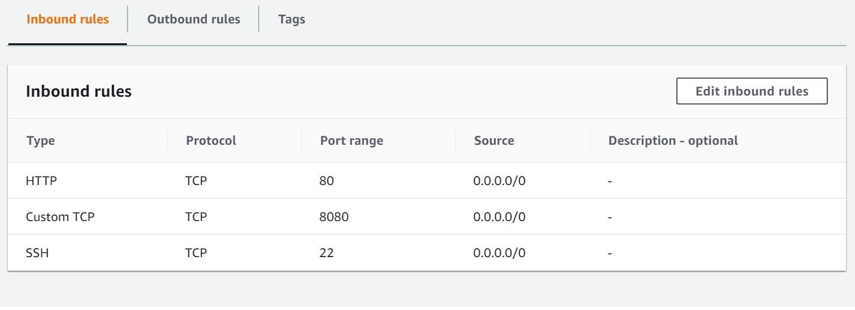

Custom TCP 🡪 8080

Step 3: Go to web browser to access

<http://34.220.28.128:8080/login?from=%2F>

34.220.28.128 – Linux EC2 host where you install Jenkins software.

8080 : Port of Jenkins service

Step 4: You will see the welcome page

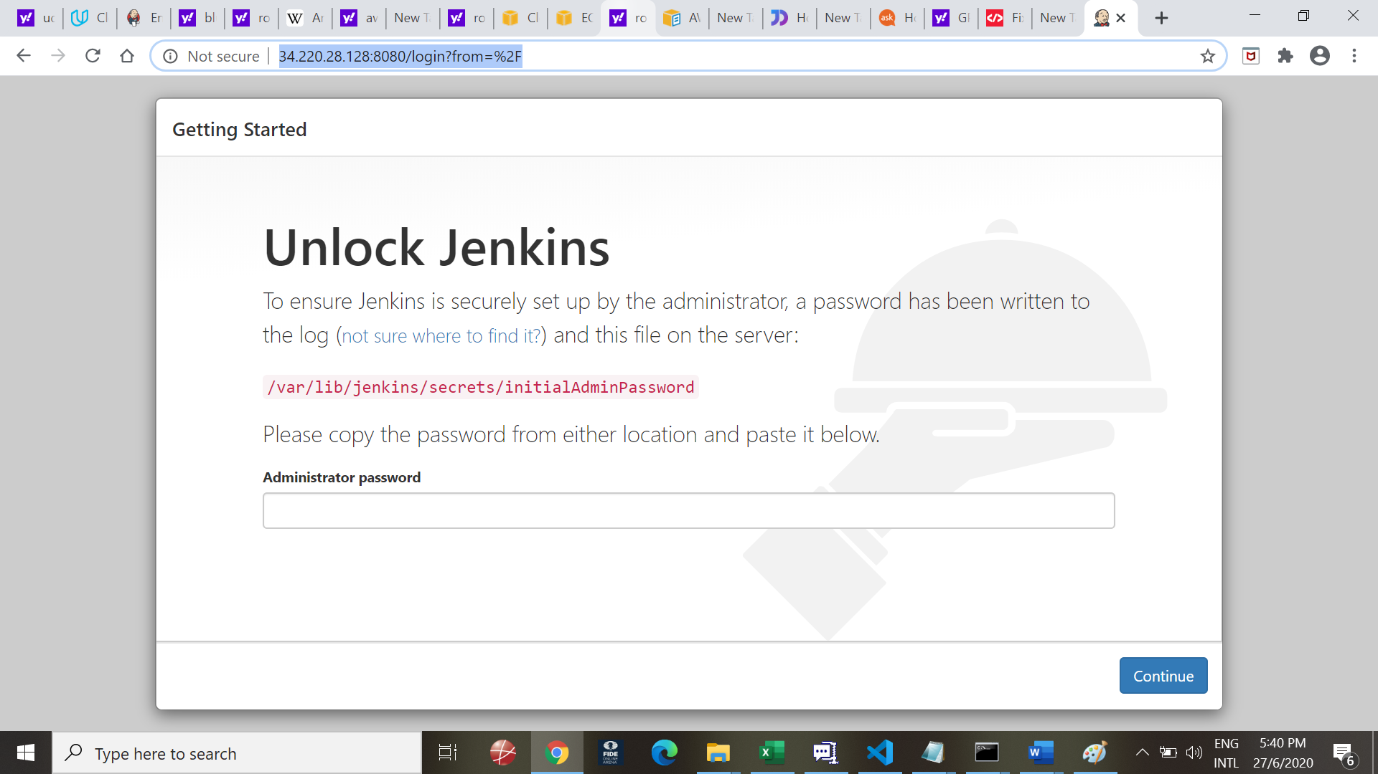

Step : Go to server and run beow command

root@ip-10-0-0-32:~#

root@ip-10-0-0-32:~#

root@ip-10-0-0-32:~# cat /var/lib/jenkins/secrets/initialAdminPassword

**f021129960fd46e883195d25dd83c3f6**

Copy the string marked above in RED BOLD and paste to window on web page above.

Step 6: You come to Customise Jenkins page

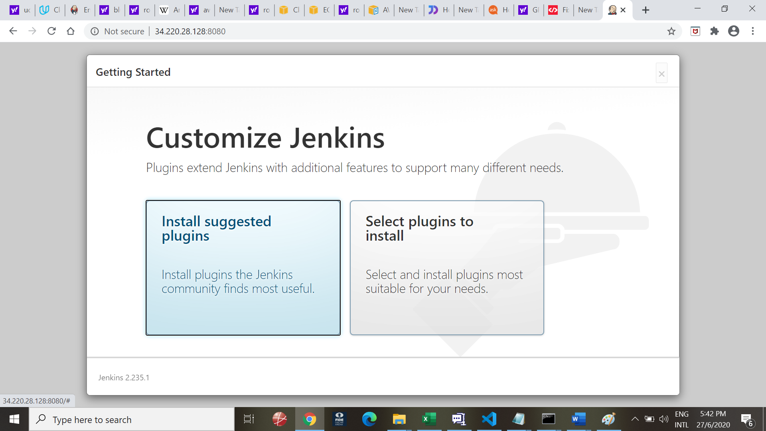

Step 7:

Choose “Install suggested plugins”

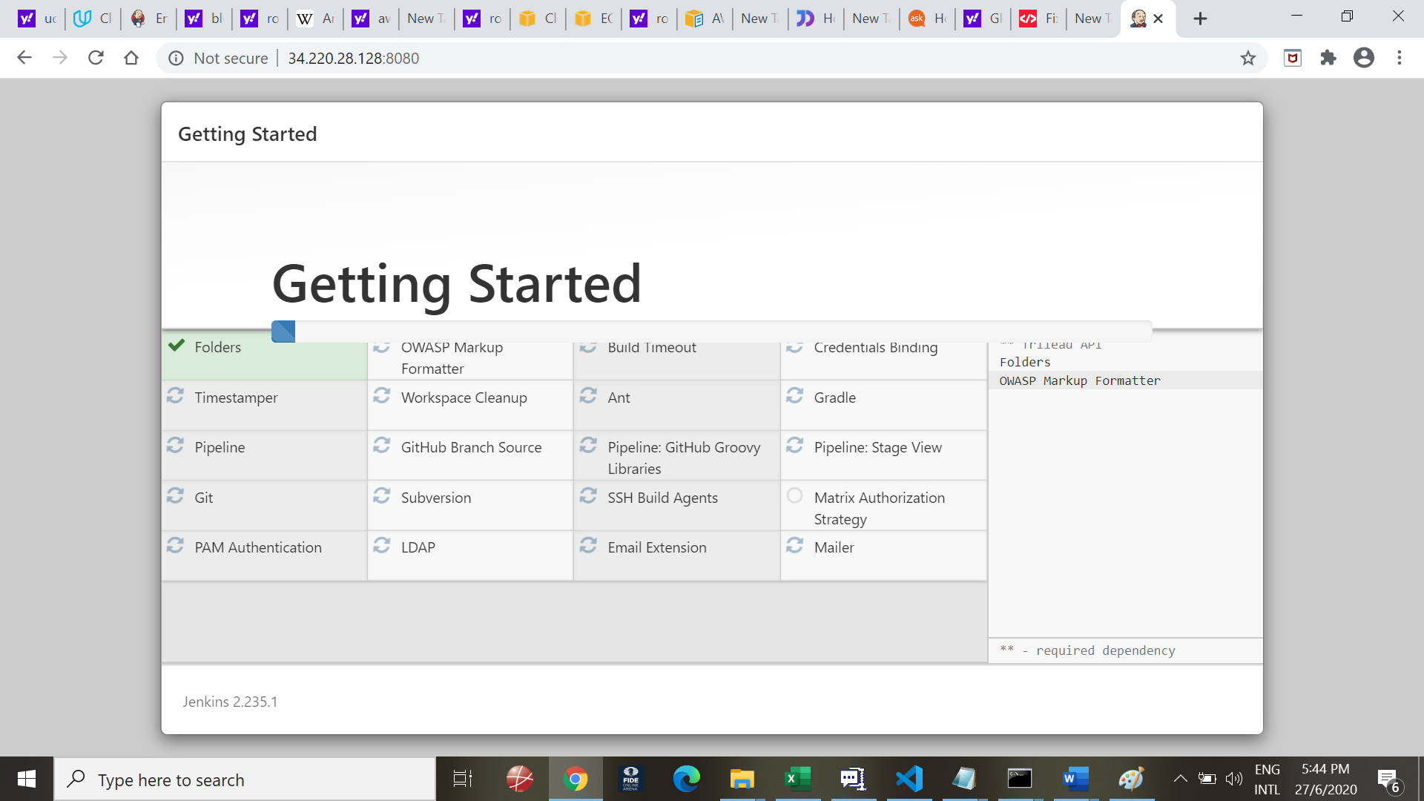

Step 8:

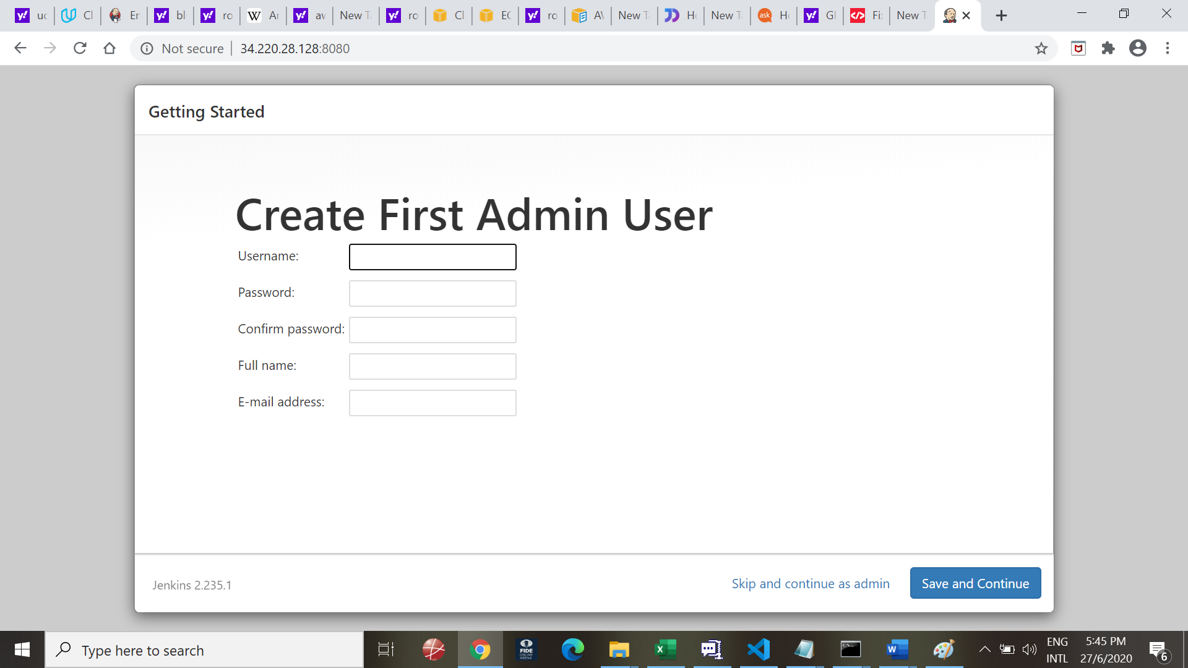

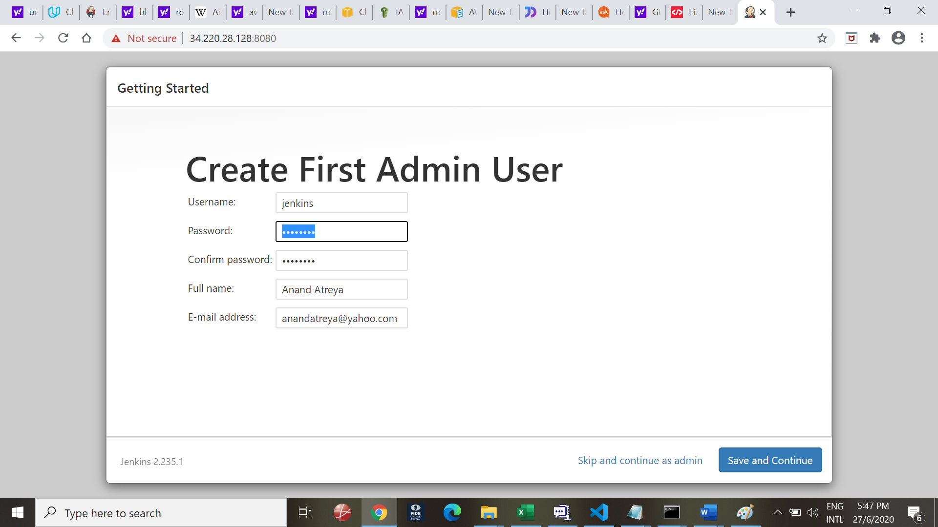

USername:Jenkins

Password: Nimda123 (Capital N)

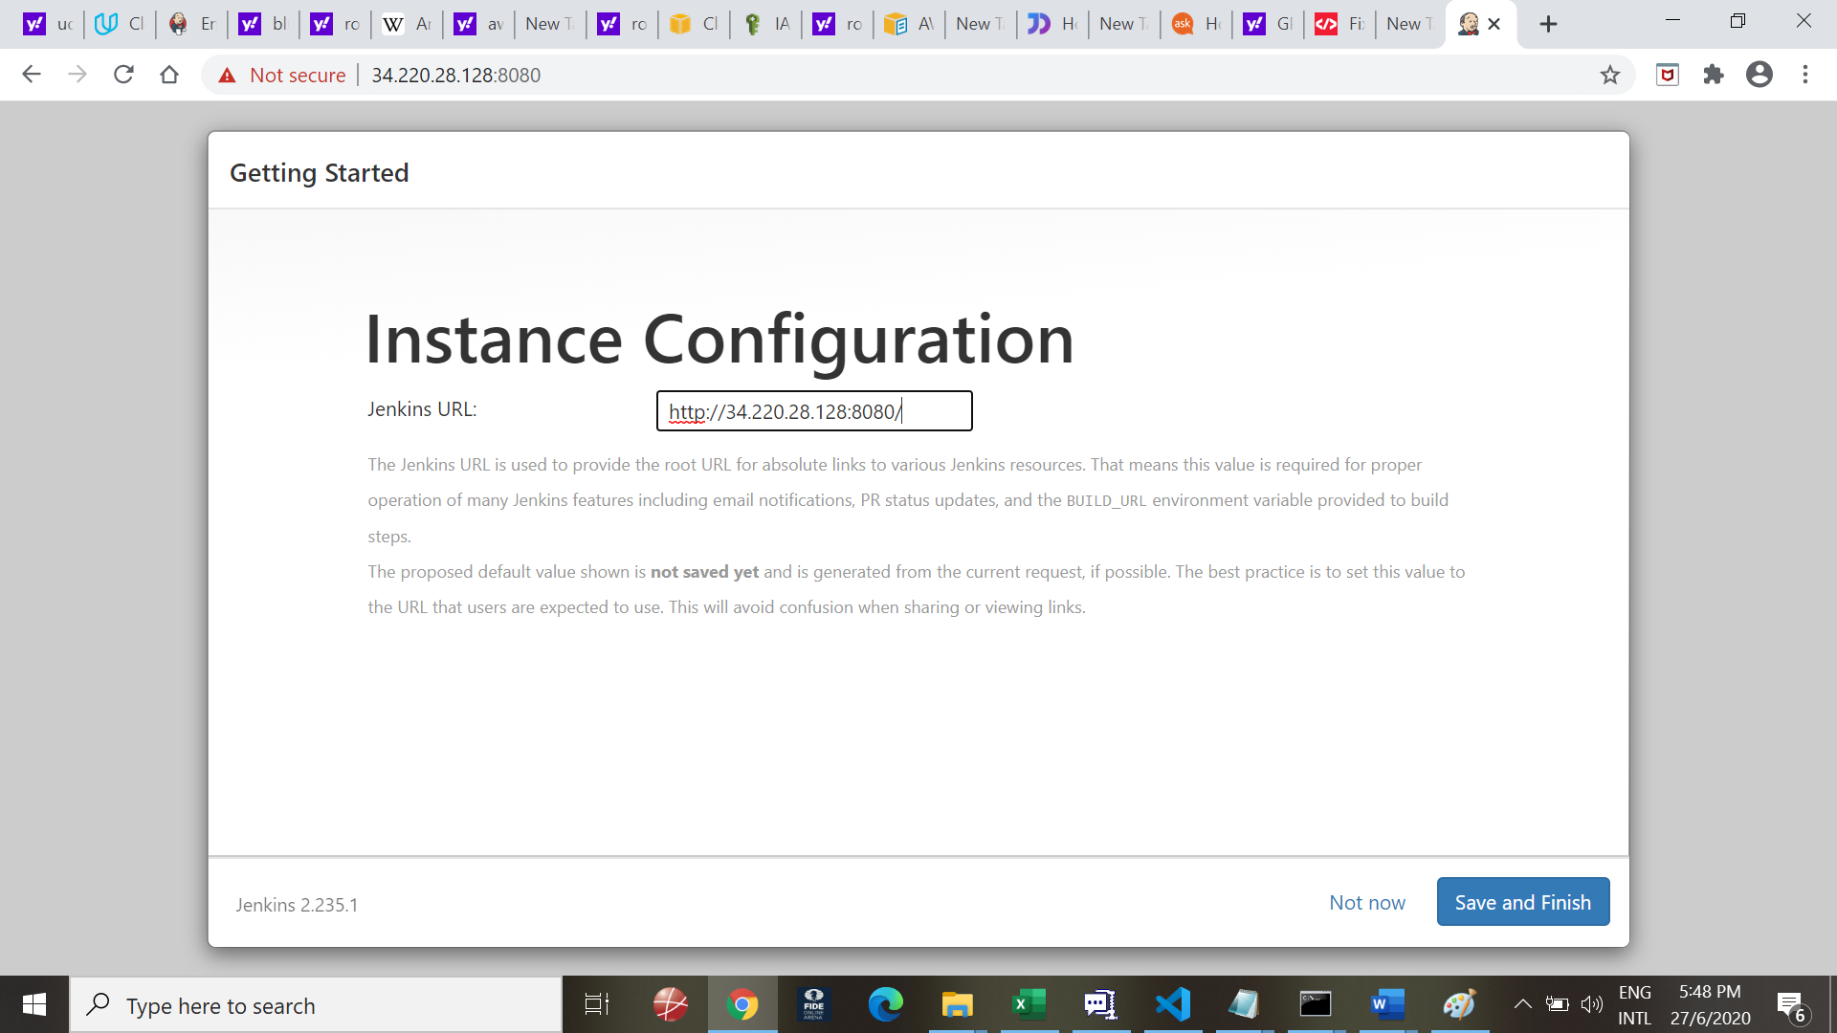

Step 10:

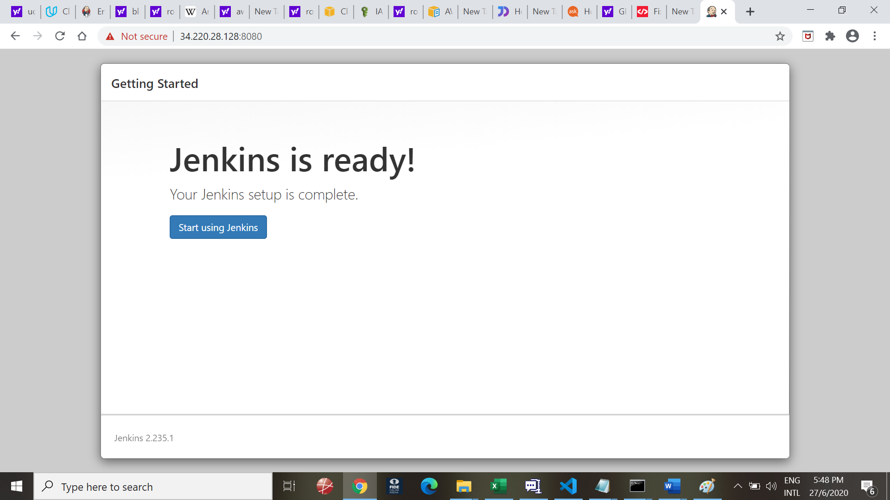

Part II - Confgure Jenkins

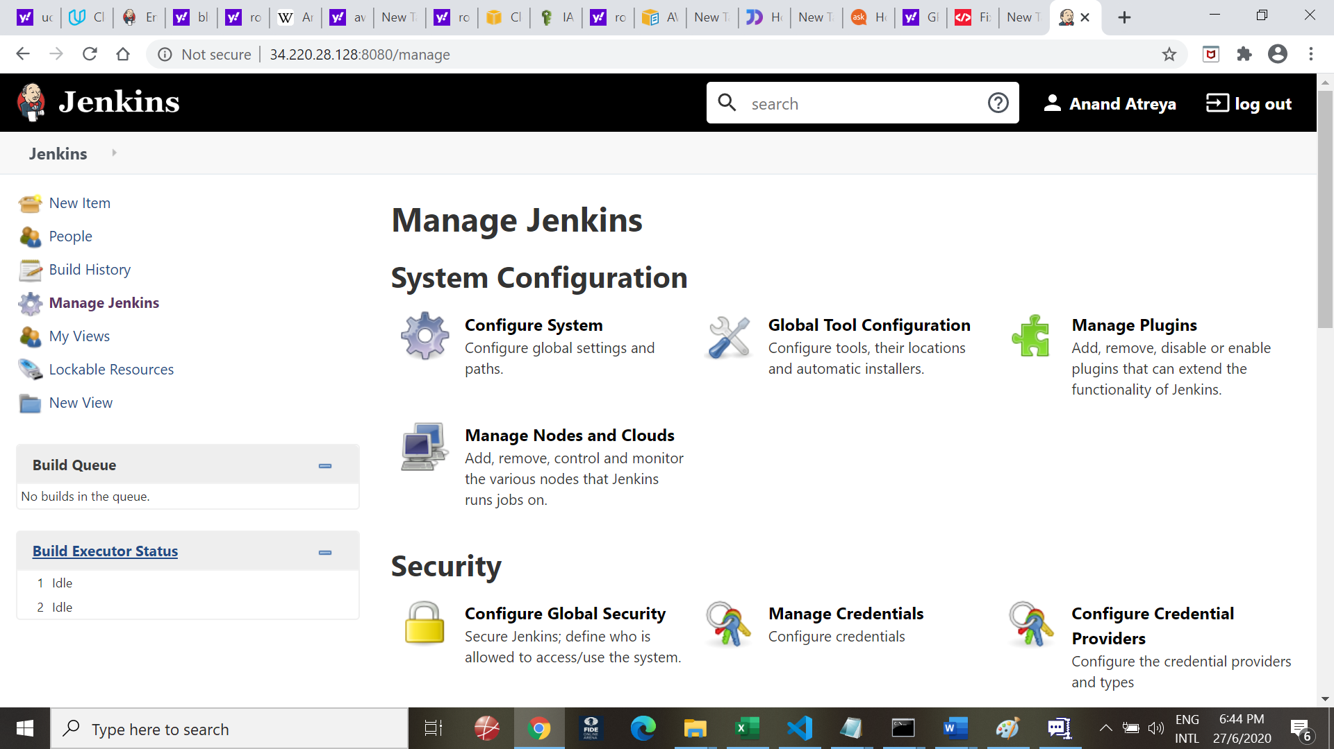

1. Install BlueOcean

Goto Manage Plugins and choose BlueOcean

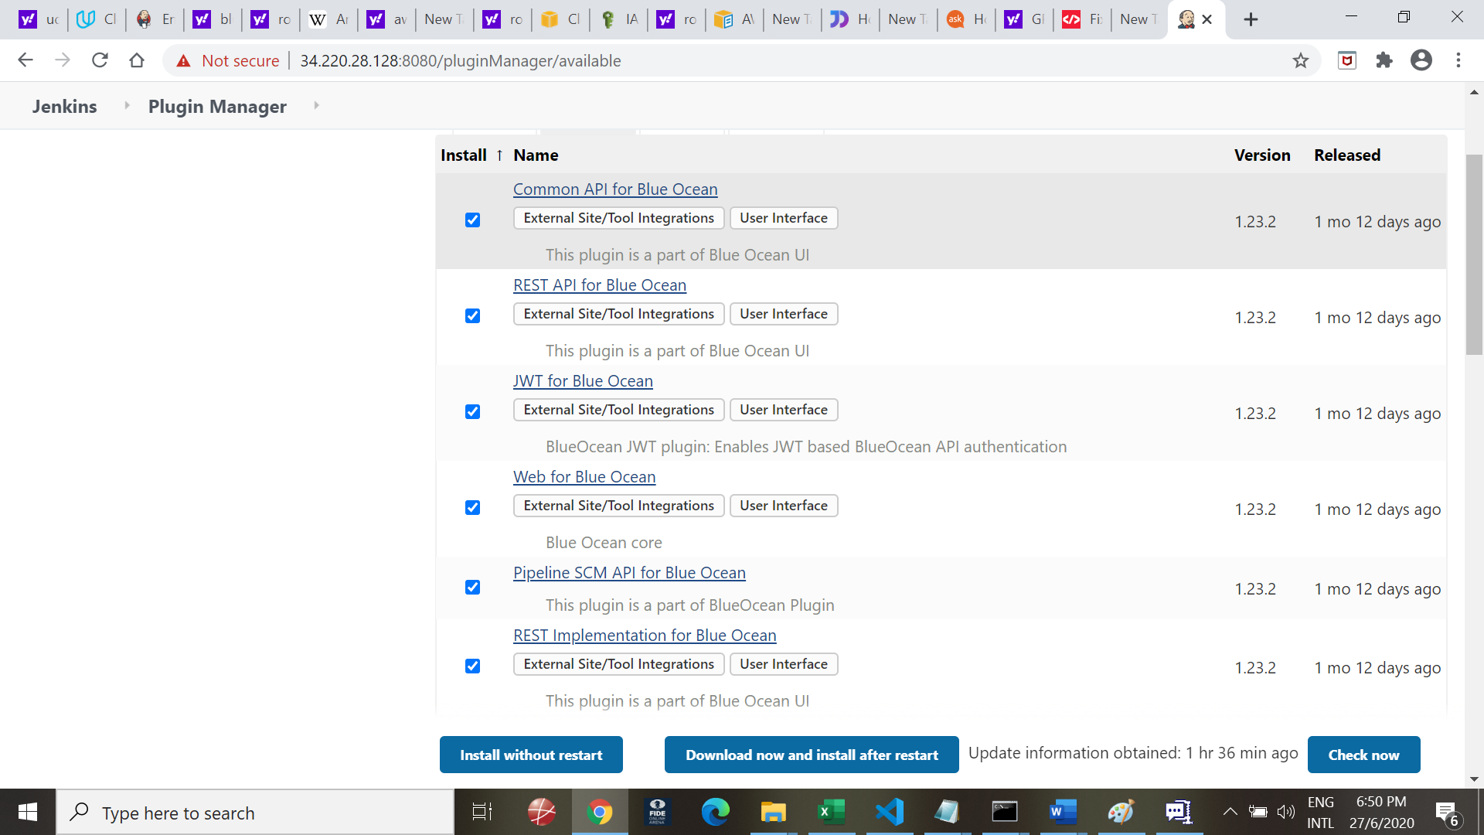

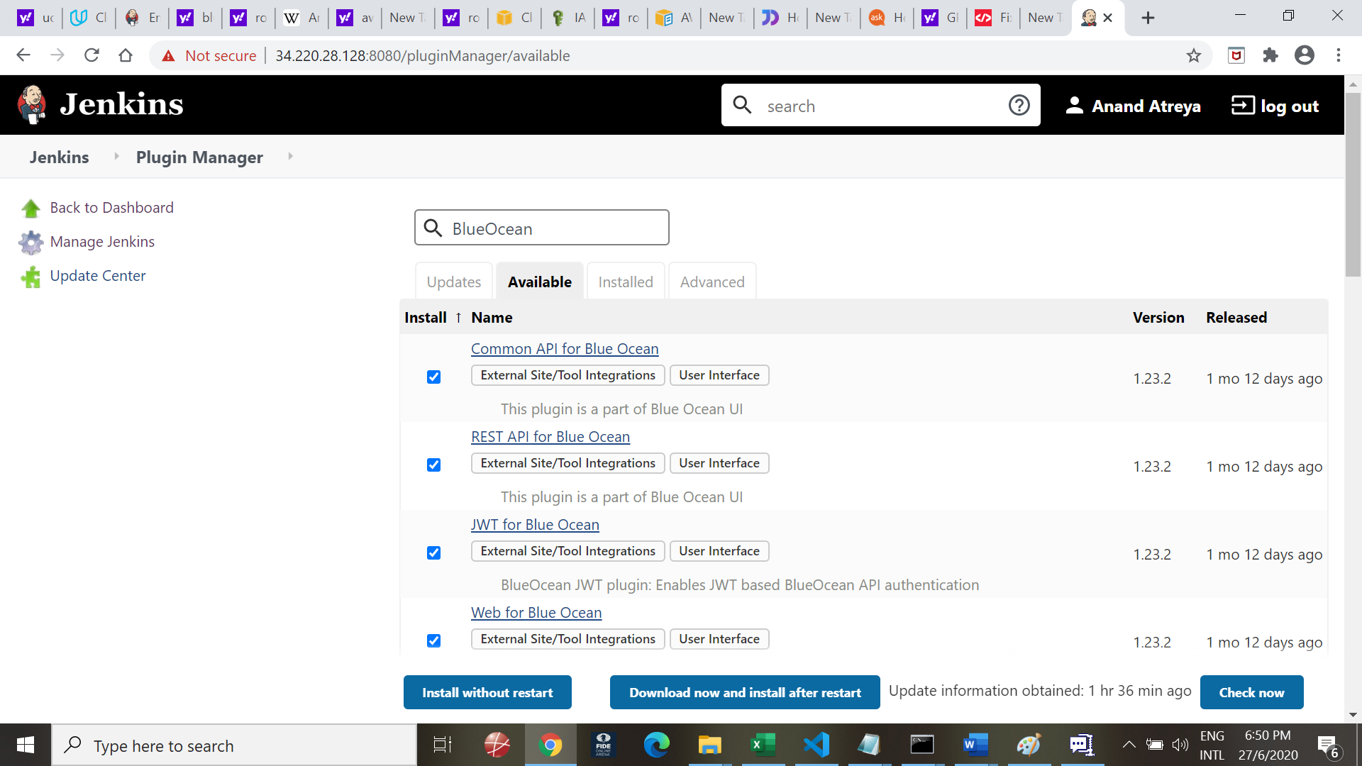

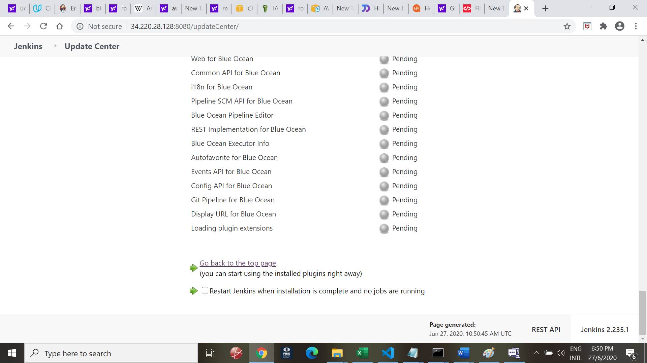

Once Installation is complete, you will need to restart Jenkins

1. Once back, you will see BlueOcean 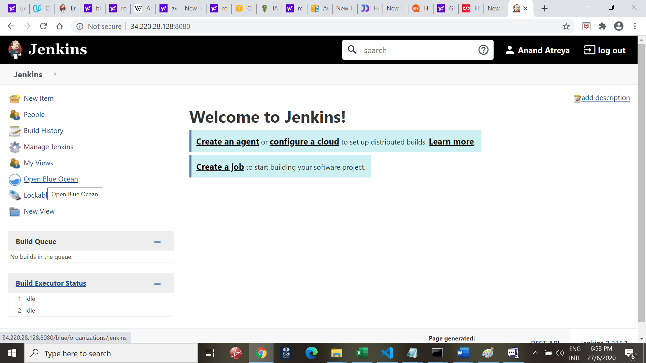
2. Install AWS Plugins

Install AWS plugins

1. Connect to GitHub

Go to BlueOcean to create a new pipeline

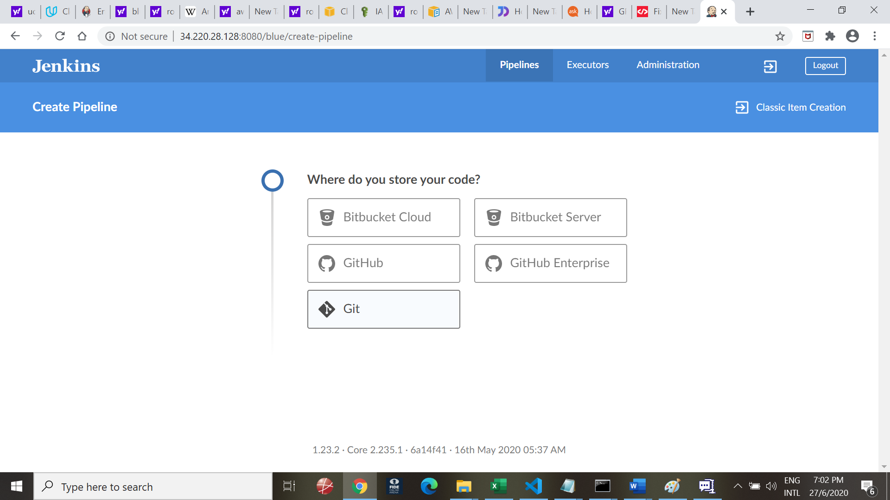

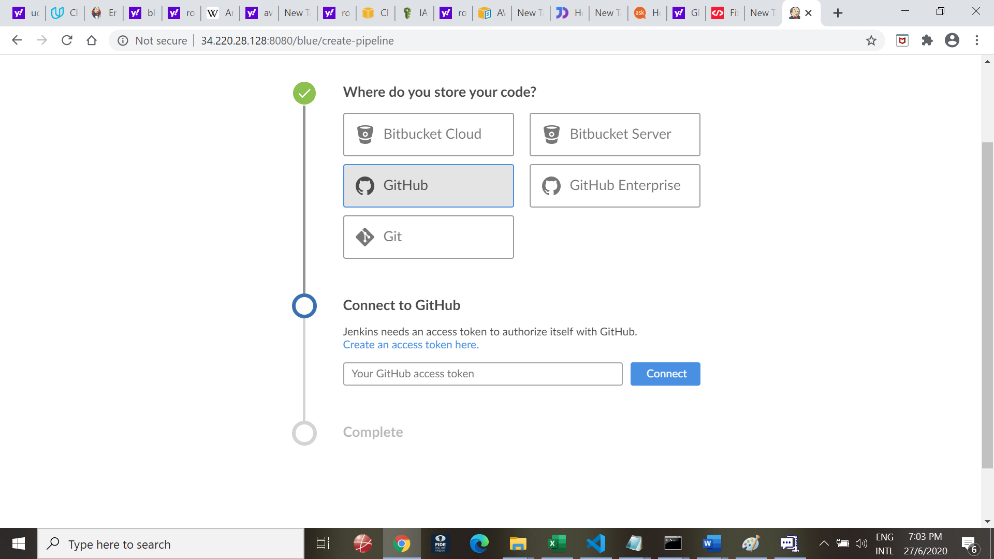

Use below token from document Notes_Module3:

6093b055d99b25aeaa2fc17fee1eab20bd20969c

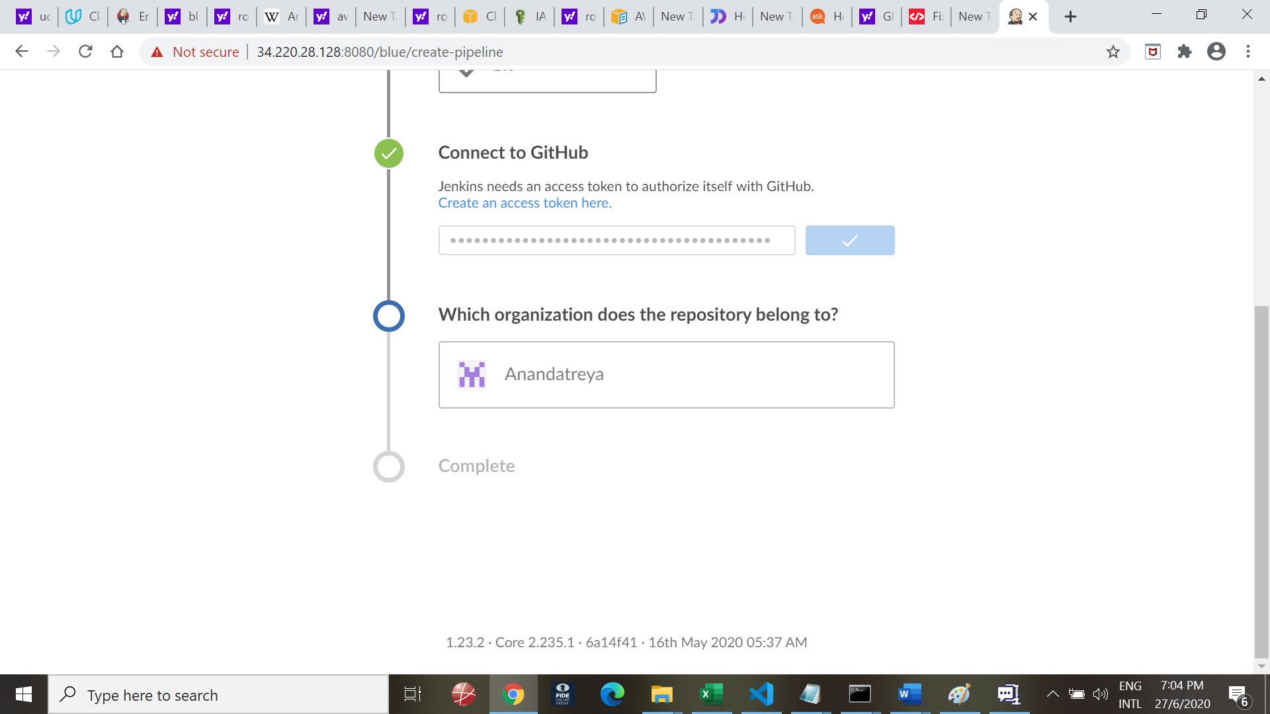

Chose Repository

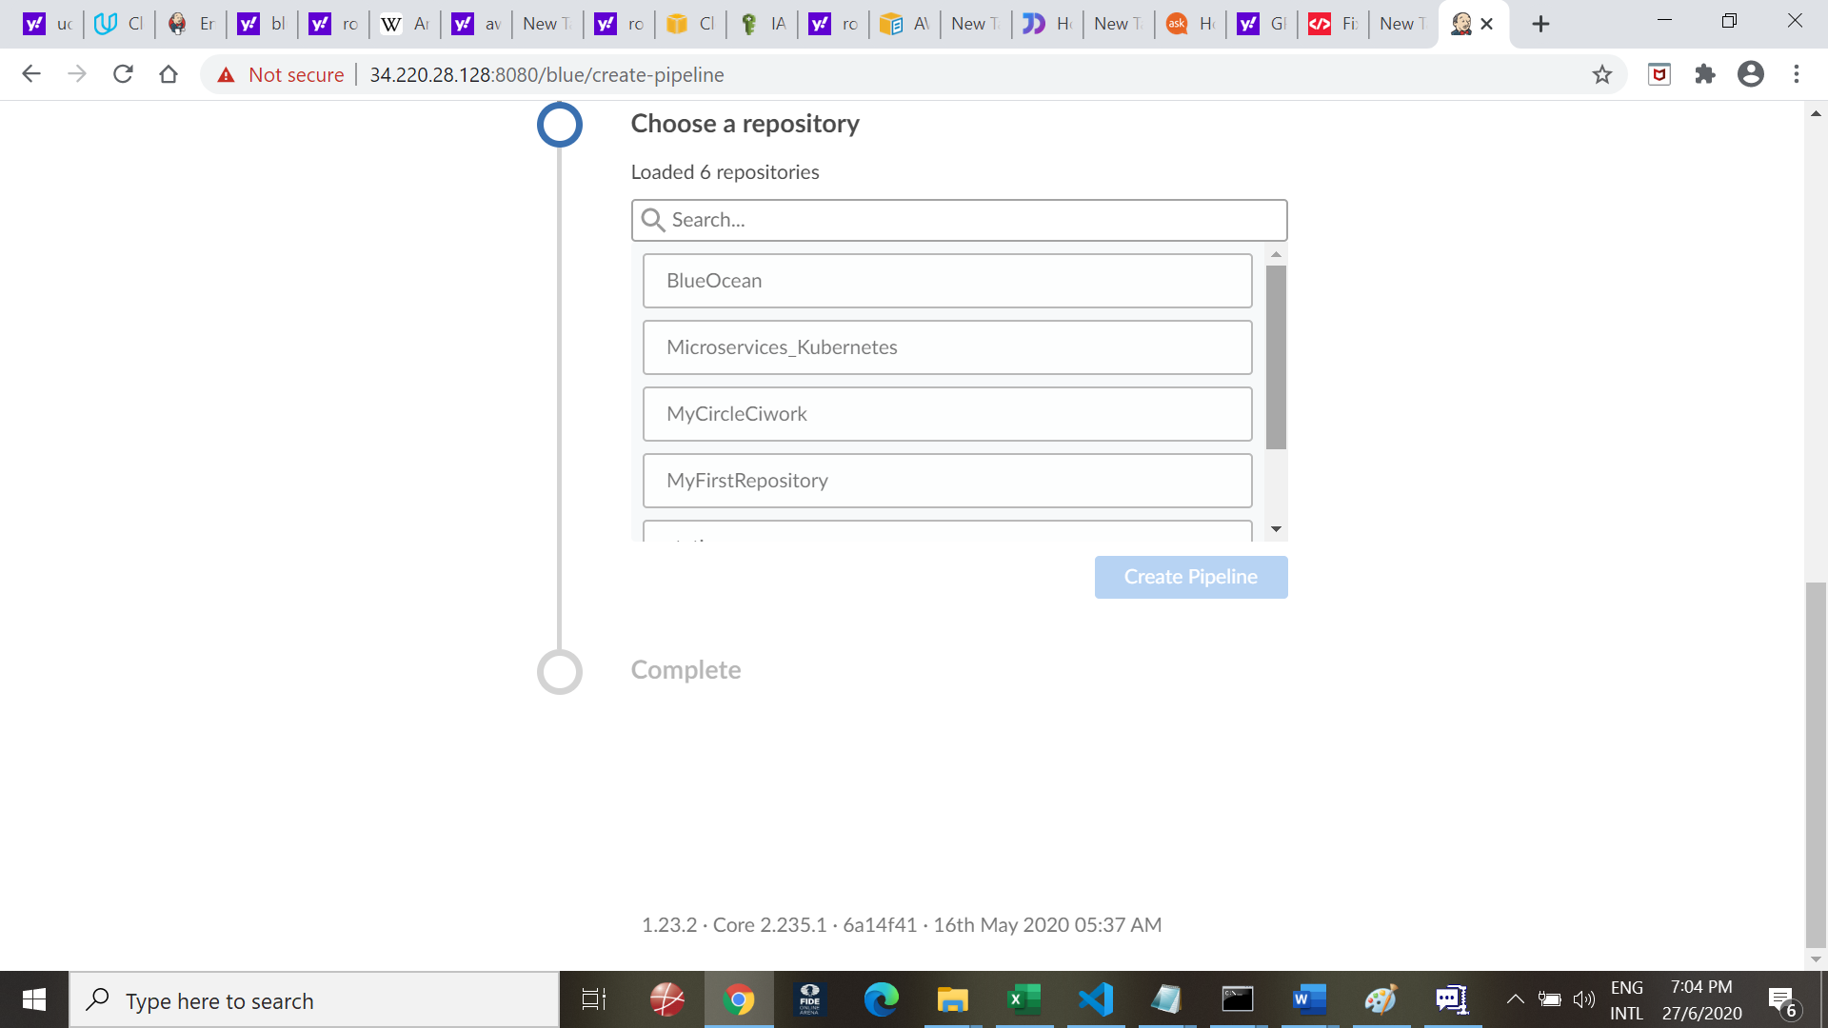

Choose BlueOcean

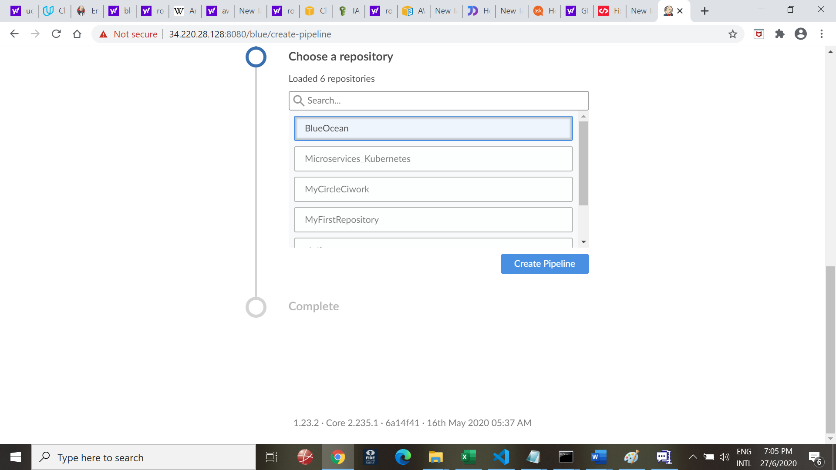

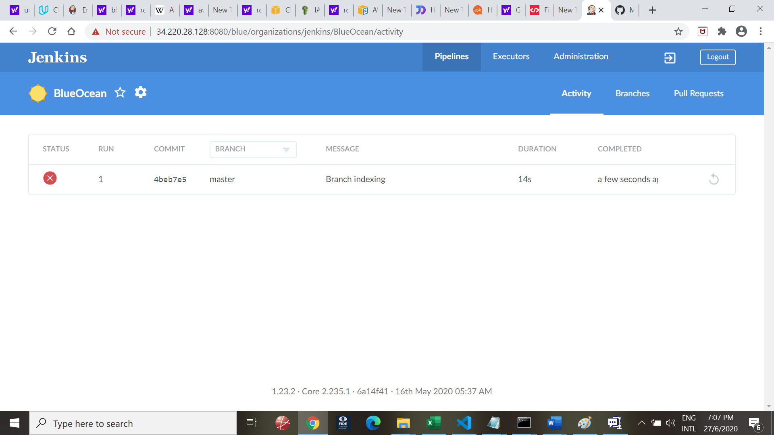

Adding credemtals

Go to Jenkins 🡪 Credentials 🡪 System 🡪 Gloal credental

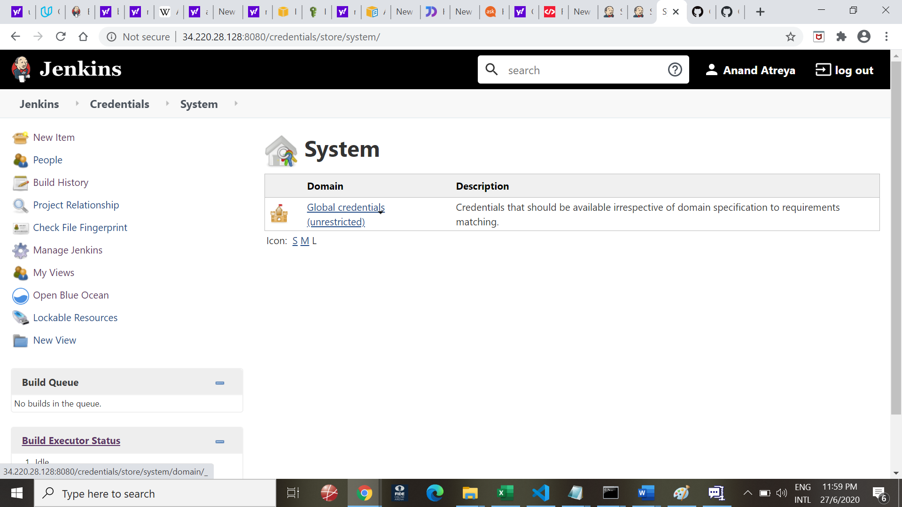

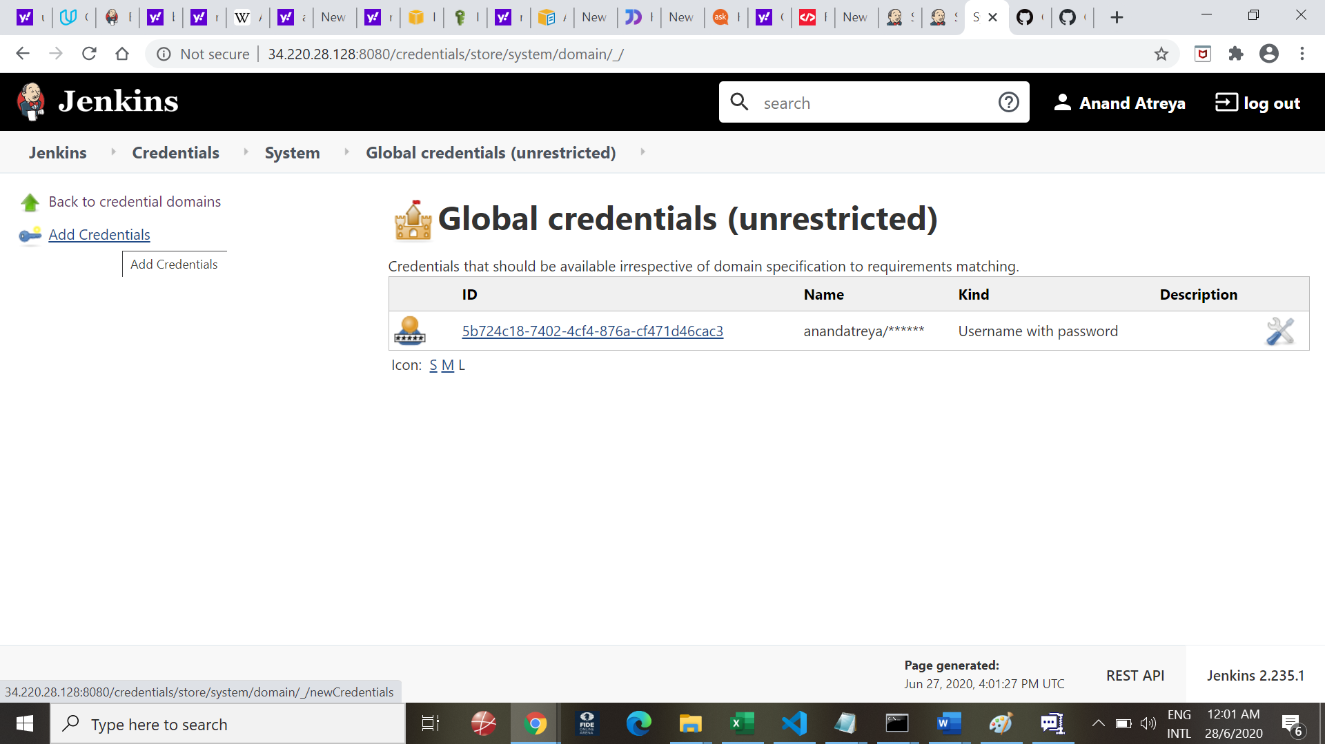

Choose 🡪 Add credentials

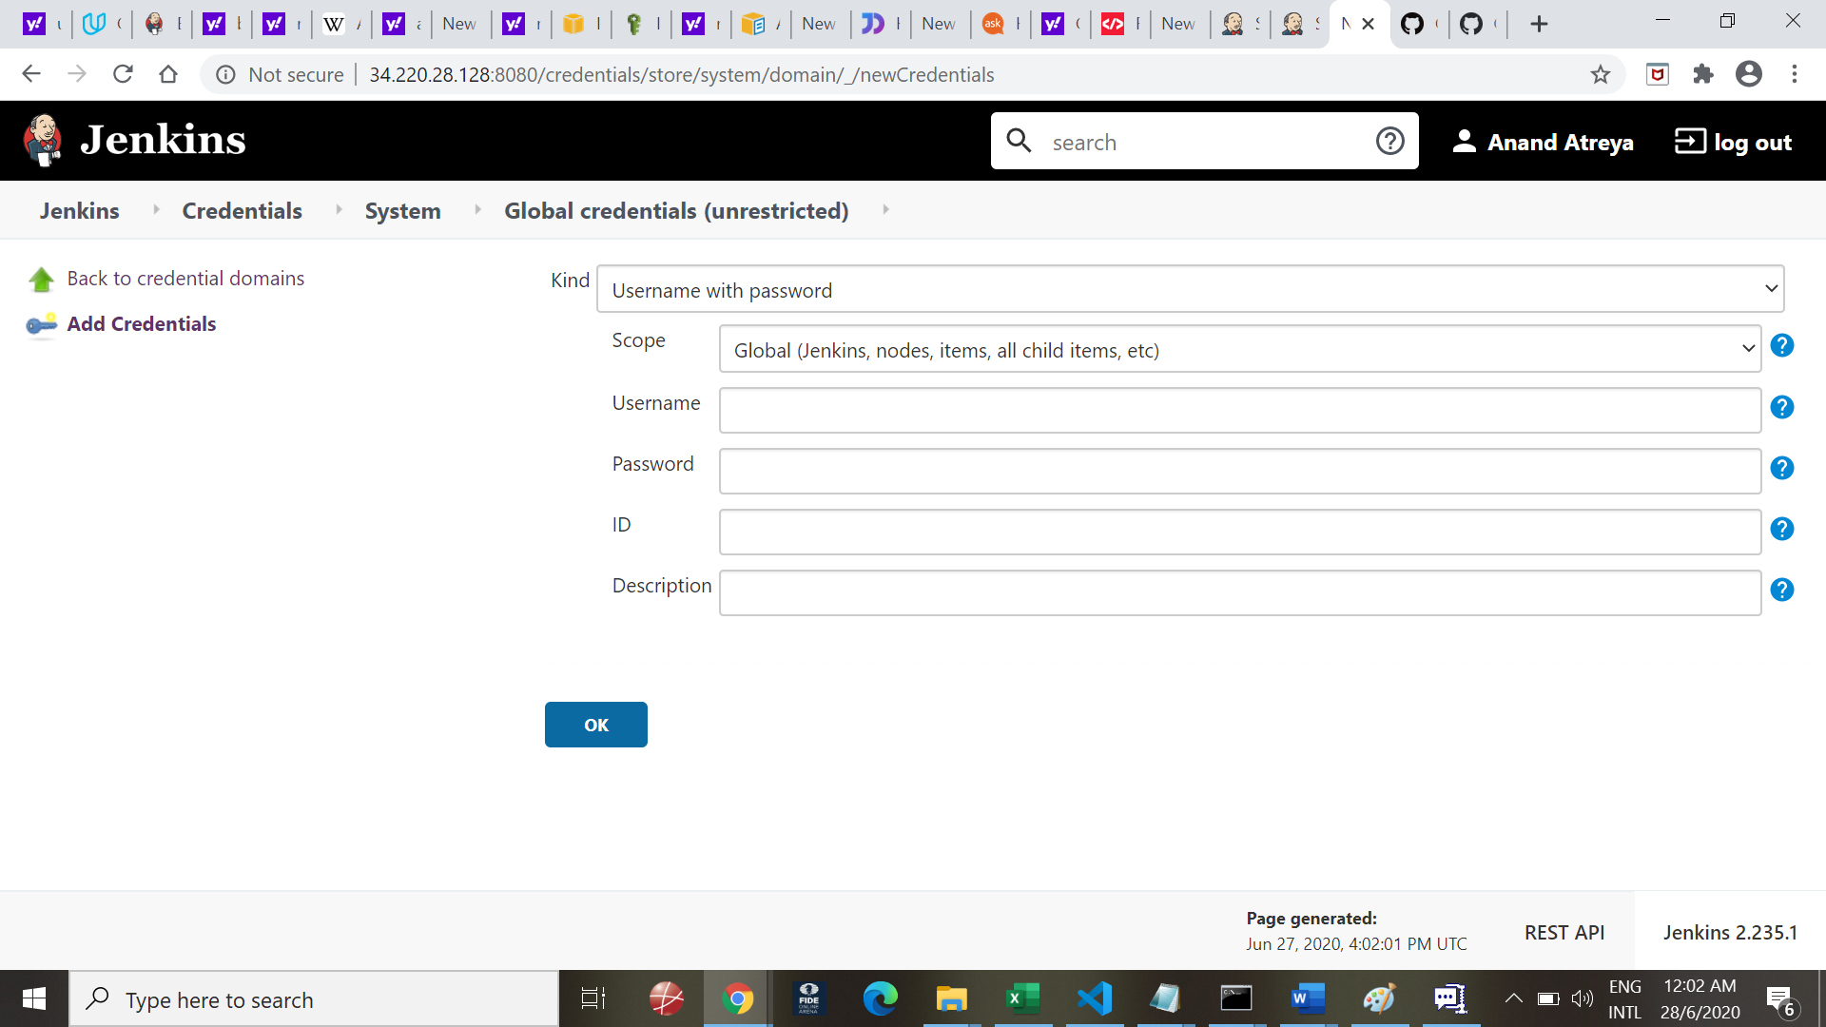

On AWS, add Cloudformation to minimum_access_policy

Add Cloudformation to the policy

